v
Audit Assignment System
contract requirements
Version 1, August 1, 2022

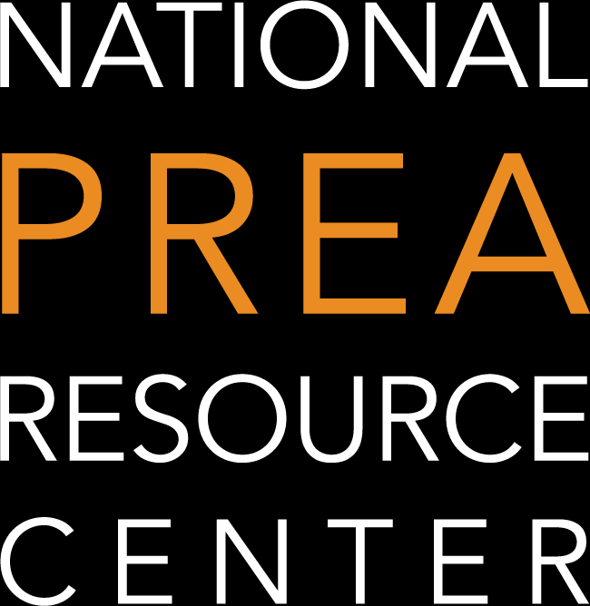
This information sheet describes the contract requirements for PREA auditors and addresses questions that have arisen during implementation of the new Audit Assignment System.

Contract submission as part of audit initiation
As part of the new Audit Assignment System that is required by the 2018 amendment to the PREA statute (see 34 U.S.C. § 30307(e)(8)(C)), auditors are required to submit a copy of the audit contract to the Department of Justice’s PREA Management Office (DOJ PMO) and confirm that they are a party to the contract or agreement with the audited facility and/or agency. Audit contracts must be submitted at the time of audit initiation and are reviewed during the approval process of the Audit Initiation Form to determine whether the minimum conditions, which are detailed below, are met. If an auditor is unable to meet one or more of the conditions and/or fails to fully and accurately complete or confirm the Audit Initiation Form, the auditor will not be approved by the DOJ PMO to proceed with the audit.
Auditors may not proceed with an audit unless and until they receive an approval email from the DOJ PMO that explicitly grants the auditor permission to conduct the audit. This approval applies only to the auditor who is named in the Audit Initiation Form as Lead Auditor. If the Lead Auditor approved to conduct the audit is unable to complete it, another auditor may not proceed as Lead Auditor without taking all audit initiation steps.

Contract requirements
All auditing agreements must, at a minimum:
- Be signed by all relevant parties, including the audited agency, lead auditor, and third-party entity (e.g., the auditor’s current employer, an accreditation body, or a consulting firm), if applicable.
And include the following information:
- The name of the Lead Auditor.
- The facility(ies) to be audited by the auditor.
- Anticipated dates for the onsite phase of the audit(s).
- With the exception of audits conducted as part of a circular auditing arrangement (i.e., audit consortium), fees, expenses, and other forms of compensation paid to the auditor for completing the agreed upon audit(s).

For a downloadable checklist that details the contract elements required by the Audit Assignment System, visit this page: https://www.prearesourcecenter.org/audit/prea-audit-assignment-system.
For a webinar we conducted on June 27, 2022 explaining the new requirements to procurement officials and others, visit this page: https://www.prearesourcecenter.org/implementation/training/webinars/prea-auditor-contracting-procurement-agencies.
These requirements apply whether the auditor is being compensated directly by the audited facility and/or agency or through a third-party entity (e.g., the auditor’s current employer, an accreditation body, or a consulting firm).

Third-party auditing organizations
Some facilities and/or agencies may contract with a third-party entity that assigns an auditor after the contract is executed. In such instances, prior to the submission or confirmation of the Audit Initiation Form, the auditor must ensure that the contract between the facility and/or agency and the third-party entity is amended or supplemented to include the lead auditor as one of the parties to the contract. (When applying this requirement, the term “contract” is defined according to DOJ’s broad interpretation to include any memorandum of understanding or intergovernmental or interagency agreement.)
During the early stages of implementing the new Audit Assignment System, the DOJ PMO understands that state procurement rules may prevent updating existing contracts. For the time being, the DOJ PMO is allowing the following: for agencies that are unable to amend or supplement current contracts, it is temporarily acceptable for the third party that contracted with the agency to incorporate the complete agency contract into its subcontracts with individual auditors and attach the full contract, provided that the necessary signatures of all parties are included, either as signatures to the auditor’s subcontract or in the incorporated agency contract, and that all other required contract elements are present. Any future changes to these requirements will be communicated to DOJ-certified auditors, third-party auditing organizations, and other relevant parties, well in advance of when changes will be implemented.

Questions raised and clarifying responses
The following questions have been raised by DOJ-certified PREA auditors, third-party auditing organizations, representatives from agencies and facilities receiving audits, and other stakeholders. The DOJ PMO and its partners at the National PREA Resource Center are offering written responses to these questions below. As additional questions are raised, this document will be updated.

Issue 1
Do the signatures in an audit contract have to be electronic, or is a handwritten signature acceptable?

Response
Electronic signature is preferable, but where not possible, another form is fine if all parties agree that the form of the signature being used is legally binding. For example, a typed name, scanned image of a signature, or actual written signature is fine.

Issue 2
Does information in the audit contract relevant to fees, expenses, and other forms of compensation paid to the auditor for completing the agreed-upon audit(s) need to detail the work done in each phase of the audit?

Response
No. The DOJ PMO expects auditors to enter contracts with sufficient detail to govern the work in a way that is satisfactory to the parties, and that is consistent with the auditor’s required responsibilities. The DOJ PMO is not requiring contracts to detail fees associated with each phase of the audit. It is acceptable for auditors to indicate whatever fee structure has been negotiated, such as a daily or hourly rate, or a rate for some other unit of work.
Please note: It is not possible to predict how much time and work a future audit will require. All DOJ-certified auditors must carry out their work under contracts that are consistent with the PREA Auditor Handbook and other documents and resources that define DOJ’s expectations of auditors.

Issue 3
Some states use a Request for Proposals (RFP) process for procuring auditing services, and frequently the resulting award includes the overall amount paid to an auditor for the conduct of multiple facilities under the governor’s operational control. Can audit contracts include this bulk price or does the price paid for each audit need to be provided?

Response
Audit contracts must disclose the fees, expenses, and other compensation paid for each audit where the auditor acts as Lead Auditor. It is fine if the contract lists more than one or lists the bulk price, as long as the information is there in the contract, or a signed attachment, to indicate the individual fees and costs for the one audit being initiated. Every audit being initiated requires an Audit Initiation Form and an uploaded contract with the five required pieces of information listed above.

Issue 4
Many contracts have terms for multiple years and may not include onsite dates for every audit included in the base agreement. In these circumstances, audit scheduling occurs after the agreement has been concluded and several weeks or months prior to the initiation of the given audit(s). How may auditors or third parties meet the audit contract requirements in these circumstances?

Response
In the circumstances described, the auditor should provide both the base agreement for multiple years and an amendment or supplement with the required signatures that provides the up-to-date schedule and other information needed to comply with all five required elements (i.e., signature of all parties, lead auditor’s name, facility to be audited, anticipated dates for the onsite portion, and fees, expenses, and other compensation).
For the time being, for agencies that are unable to add individual auditors to be parties to an already granted contract under an RFP, a signed subcontract for the Lead Auditor that includes the entire base multi-year agency contract as an incorporated attachment will also satisfy the requirement that the contract include signatures of all parties. In this case, the third-party organization to win the multi-year contract and the auditor for the individual audit must sign the subcontract, and the other required contract elements must also be included.

Issue 5
Will the Audit Assignment System impact existing contracts for audits?

Response
The intent of the Audit Assignment System is not to replace or interfere with existing PREA auditing contracts, relationships between parties that have entered into a contractual arrangement for the conduct of audits, or scheduled audits. However, after June 30, 2022, any newly initiated audit is expected to meet the requirements outlined in this document, including those where the contract was in place prior to June 30, 2022. In the months after the implementation of the Audit Assignment System, the DOJ PMO is taking a flexible approach for contracts where the parties, including the individual auditor, have made a good faith effort to submit information that complies with all five elements defined above. As emphasized above, any future changes to the requirements defined in this document will be communicated to DOJ-certified auditors, third-party auditing organizations, and other relevant parties well in advance of when changes will be implemented.

Issue 6
How long will it take to get approval once everything is submitted?

Response
It will take 2-3 business days for contracts that include all required information. If all the required elements are not in the contract or agreement, the DOJ PMO and the PREA Resource Center will send a notice to the auditor describing the insufficiency within three business days of the audit initiation submission. Then the auditor needs to submit a contract with the necessary information. Once it is provided, the review process starts again under the same time frames.

Issue 7
Will the facility or agency receive notice if the contract is found not to be sufficient?

Response
No. Notice will only go to the auditor who uploaded the contract.

Issue 8
If the on-site date changes after the contract is signed, does it require a new contract or can it be updated with a form?

Response
Date changes may be reported during audit initiation without changing the contract, by completing the Audit Initiation Form with the adjusted dates, or by attaching an addendum to the contract. If the date changes occur after audit initiation, the auditor must submit the changes via the Audit Change Form, so that the DOJ PMO has accurate information about the dates of the audit.

Issue 9
Does the lead auditor receive an email that shows they have been approved to continue, which could be provided to the procuring agency?

Response
Yes.

Issue 10
Will there be standardized language required for the contract content?

Response
No. However, keep in mind that the Auditor Handbook, the Auditor Code of Conduct, the PREA Standards, and FAQs issued by the DOJ PREA Working Group include many requirements in order to conduct an effective audit. Contracts should require that auditors abide by all requirements of their DOJ-issued certifications.

Note: This is Version 1 of this guidance, dated August 1, 2022. As patterns emerge from contract review, the DOJ PMO may update the guidance and the PRC will share it with the field.
Notice of Federal Funding and Federal Disclaimer
This project was supported by Grant No. 2019-RP-BX-K001 awarded by the Bureau of Justice Assistance. The Bureau of Justice Assistance is a component of the Office of Justice Programs, which also includes the Bureau of Justice Statistics, the National Institute of Justice, the Office of Juvenile Justice and Delinquency Prevention, the Office for Victims of Crime, and the Office of Sex Offender Sentencing, Monitoring, Apprehending, Registering, and Tracking. The opinions, findings, and conclusions or recommendations expressed in this publication/program/exhibition are those of the author(s) and do not necessarily reflect the views of the Department of Justice or grant-making component.

