Have you experienced sexual abuse or sexual harassment?

Sexual abuse is any unwanted sexual touching or activity.
Sexual harassment is any unwanted sexual comment or gesture.
This facility has a rule called zero tolerance. Zero tolerance means we do not allow sexual abuse or sexual harassment.
If someone has sexually abused or sexually harassed you, you can report it. You will not get in trouble for reporting. Here are 4 ways to report:
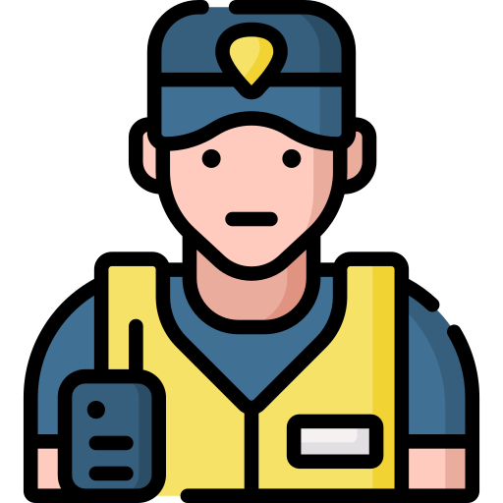  Report to Staff | Zayn reports to staff. He asks to talk to an officer. Zayn tells the officer that someone touched his penis without permission. Someone touching Zayn’s penis without permission is sexual abuse.  The officer will tell someone in charge about Zayn’s report.

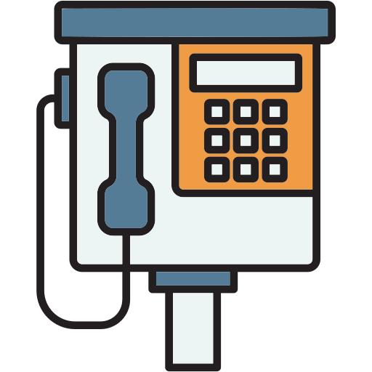  Report by Phone | Keisha reports by phone. She calls [XXX-XXX-XXXX] on the phone.  A person or message says Keisha can report a problem. Keisha says that someone keeps saying things about her breasts. Someone repeatedly talking about Keisha’s breasts is sexual harassment.  Someone who works here will listen to Keisha’s phone call.

  Report by Mail | Owen reports by mail. He writes a letter. The letter says that someone who lives here has asked Owen to have sex. Owen said no, but the person keeps asking. Another resident continuing to ask Owen to have sex after he said no is sexual harassment.  Owen puts his letter in a box [location]. Someone who works here will read his letter.

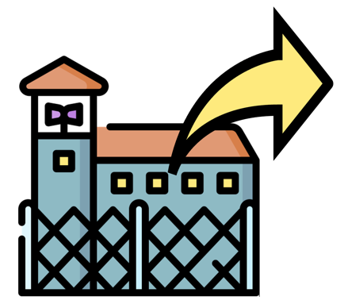  Report Externally | Salma reports a problem to someone outside of the facility. She writes a letter. The letter says that someone forced Salma to have sex. Someone forcing Salma to have sex is sexual abuse. She sends her letter to [address for external reporting].  Someone from outside the facility will read it. The person will talk to the people who work here.

When you report sexual abuse, we will do things to protect you. We will separate you from the person who hurt you. We will help you get care. We will also have an investigator talk to you.
If someone has sexually abused or sexually harassed you, and you don’t want to report it, you can still get help. You can talk to an advocate by calling [XXX-XXX-XXXX] on the phone. The advocate will provide emotional support to you. The advocate will not tell us that someone sexually abused or sexually harassed you.

