Module 2: Legal Issues and Agency Liability: Guidance for the Field

Time: 10:30 a.m. – 11:45 a.m. (1 hour and 15 minutes)

Training Objectives:
- Identify the steps to take to prevent or mitigate legal liability through the investigative process.
- Understand the use of, and the difference between, Miranda and Garrity, as required by PREA standard 115.(3)34.
- Apply an understanding of Miranda and Garrity to conducting successful investigations.

Materials Needed:
1. Easel pad and markers
2. PowerPoint® player/machine (laptop computer and LCD projector)
3. Screen or monitor
4. Handout: Legal Issues and Agency Liability Handout

This module has been developed over many years and includes legal research and work provided by American University, Washington College of Law, and Jeff Shorba.

Training Tips:
- Trainers should consider inviting a representative from the agency’s Human Resources or Legal Department to co-present or present this module. This may enhance the discussion of the case law.
- Trainers may want to add lawsuits specific to their agency or their state to this module to engage their audience. Additionally, trainers should view the case law provided in this module as a suggestion – remove cases that are not appropriate for your agency, such as those specific to juvenile/adult. Include those cases that seem most applicable to the training participants and your agency.
- An investigation mapping scenario specific to issues addressed in this module has been provided and is located at the end of the module. If you remove slides from this training,
consider inserting the Scenario activity twice: once following the Miranda and Garrity section at the beginning of Module 2, and once at the end of Module 2. Have participants conduct the Scenario activity following the Miranda and Garrity section and then report out. At the end of the module, have participants re-form their previous groups and again conduct the Scenario activity, deciding what they would do differently following the second half of the module.
- Be advised that this module may contain material that utilizes concepts and language that may be upsetting or difficult for some participants. This may include statements referring to genitalia, sexual harassment, sexual abuse, trauma and suicide. Videos used may also contain profanity. Please review all materials prior to using to ensure they are appropriate for use in your agency and make substitutions where needed. You should also consider providing a general notice to participants at the beginning of each training session.
- Please note that this module was developed specifically for facilities that use the Adult Prisons and Jail or Juvenile PREA Standards. Facilities using the Community Confinement or Lockup standards should review all standard references to ensure that the content and language is appropriate for their facility type and inmate/resident population and adjust the material as needed to their specific circumstance.

Time | Lecture Notes | Teaching tips
1 min | Module 2 Legal Issues and Agency Liability:  What Investigators Should Know  In this module we are going to talk about legal liability in investigating allegations of sexual abuse and sexual harassment in custodial settings.  You have influence and a responsibility in your role as an investigator to ensure allegations are responded to in an effective and professional manner. This module is designed to increase your awareness of the liability issues that exist around sexual abuse in confinement settings in general, and in investigating sexual abuse incidents in particular.  As always, it is important to reach out to your legal department if you have any questions regarding the legality of a situation or a liability you may identify. |   Legal Issues and Agency Liability: What Investigators Should Know
.5 min | Module 2: Objectives  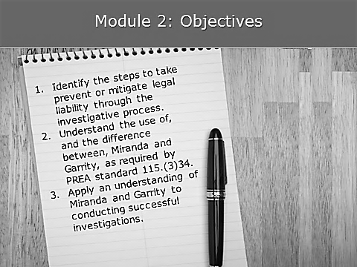 | Objectives  Ask the class if they know what is meant by these terms.
.5 min | Miranda and Garrity    A requirement of PREA standard 115.(3)34 is for investigators to be trained on Miranda and Garrity warnings. | Miranda and Garrity  Experienced investigators may feel that this is basic information. However, many facility investigators who have little to no investigative training need this information with a robust classroom discussion. Encourage discussion throughout this module.
1 min | Video  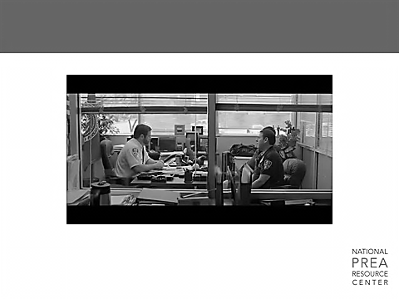 |   It is recommended that trainers consider the inclusion of a video clip here to add humor to the module. One possible video is the Miranda Rights scene from 21 Jump Street, which can be found on YouTube at the following link:  https://www.youtube.com/watch?v=T45aF1NLMyM
1 min | Miranda v. Arizona (S.CT. 1966)  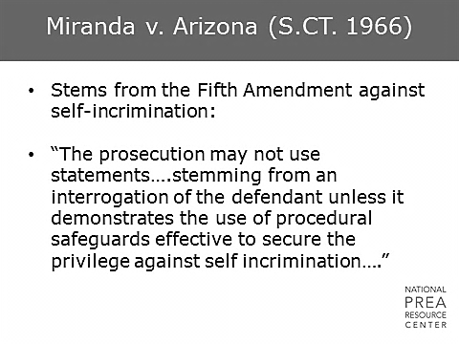  What is Miranda? We’ve all heard of the constitutional right not to incriminate yourself. | Miranda v. Arizona
1 min | Miranda v. Arizona (S.CT. 1966)  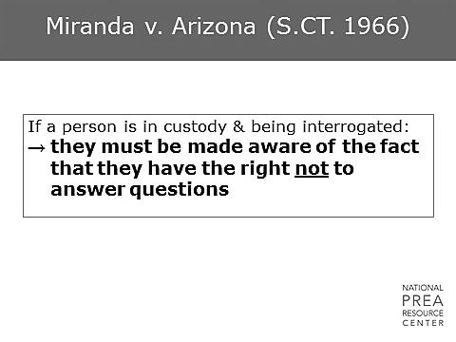  - Miranda is a warning read in the event of a custodial interview.  - Since a suspect has a 5th Amendment right not to incriminate him or herself if they are in a situation where they are in custody and being interrogated, they must be made aware of that right.  - Note that you only need to read someone their Miranda rights if you are asking them questions. If you are building a rapport, you can wait to read the Miranda rights until immediately before you begin the questioning part of the interview. | Miranda v. Arizona
1 min | Berghuis v. Thompkins (S. CT. 2010)  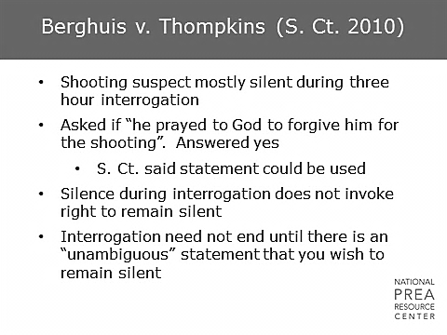  How does a suspect demonstrate his or her desire to remain silent?  - They actually need to state their desire to remain silent. Just being silent does not invoke that right.  - In this case, the suspect’s answer of “yes” was used to convict him and the guilty finding was upheld. | Berghuis v. Thompkins
.5 min | Miranda v. Arizona (S.CT. 1966)  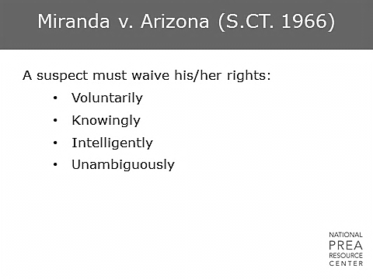  If a suspect wishes to waive his or her rights, give them their rights in writing and have them sign that piece of paper. Best practice is to actually record the warning. This record will help you avoid claims of confusion later on. | Miranda v. Arizona
1 min | Miranda  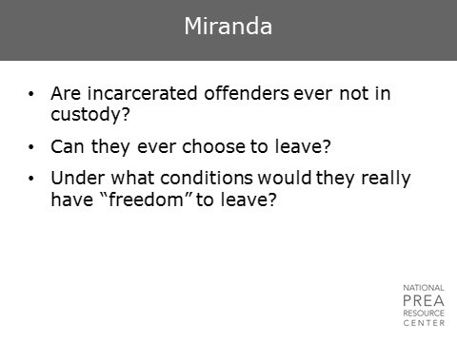  - Are prisoners in custody?  - If someone is in prison, do you need to give them the Miranda warning? Yes. | Miranda
1 min | Howes v. Fields (S. CT. 2012)  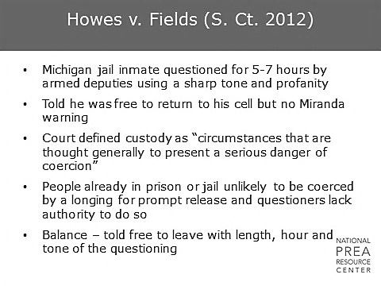  - This is a Supreme Court case in which it was determined that people already in custody are unlikely to be coerced by their longing for release.  - However, the length of time of the interview, the tone of the questioning, and the timing may impact this. | Howes v. Fields
1 min | Miranda  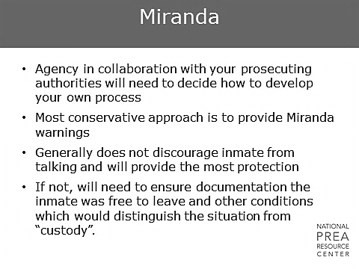 | Miranda  Insert agency requirements regarding the use of the Miranda warning. Must it always be used? Best practice is to always use Miranda.
1 min | Garrity v. New Jersey  (S. CT. 1967)  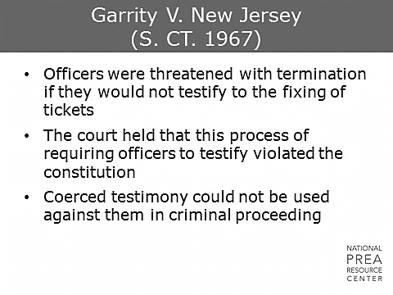  What is Garrity?  If an agency’s policy requires employees to cooperate with investigations and tell the truth under threat of termination, investigators need to warn them of that fact and emphasize that any statements made will not be used against them in a criminal proceeding. | Garrity V. New Jersey
1 min | Garrity  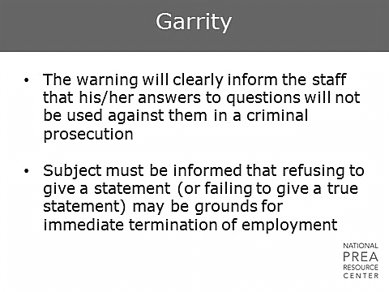  - The warning must clearly inform the staff member that their statements will not be used in criminal proceedings, and that they may be disciplined or terminated if they choose not to cooperate.  - This means that the Garrity warning should never be used if there is any chance that the information established in that interview will be used in a criminal proceeding. | Garrity
1 min | Garrity: The Investigative Process  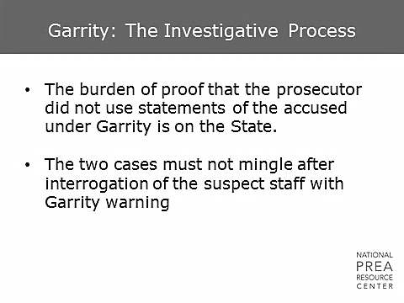  - If you interview a staff member who is a suspect in a criminal case before the case goes to trial, and you receive information from that staff member regarding their guilt, the burden of proof is on the prosecutor to demonstrate that information was not shared from those interviews with the criminal investigators.  - This is a very difficult thing to prove, since it involves proving that no communication took place or that the investigators were ignorant of the staff member’s guilt. | Garrity: The Investigative Process
1 min | Garrity: The Investigative Process  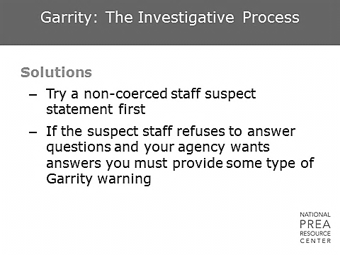  - What should you do? If you need to interview the staff member before the criminal case is complete, try a non-coerced interview.  - This means that you would not threaten staff with termination, which would make it a coerced interview. | Garrity: The Investigative Process
.5 min | Garrity: The Investigative Process  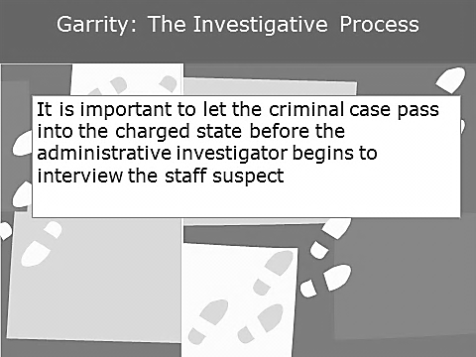  Alternatively, let the criminal case move forward with the awareness that it may last for months or even years. | Garrity: The Investigative Process
1 min | Court Approach  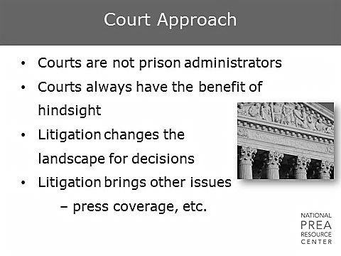  Technically, courts do not run or oversee prisons, but they will sometimes take that role during lawsuits and tell you what you should have done with the benefit of 20-20 hindsight. Administrators make decisions with the information they have in front of them at the time. So, the question here is how do you get the best information possible to make the right decisions and either avoid litigation in the first place or make decisions that will be supported by a judge.  How many of you have been sued or been involved in litigation at some level?  When you have litigation, what comes along with it? Lawyers. And what do lawyers require? Money. Litigation may also involve media coverage and bad publicity. These are all reasons to avoid litigation. | Court Approach  Pause for show of hands. It is usually the majority of people in the room.
1 min | What The Court Looks For  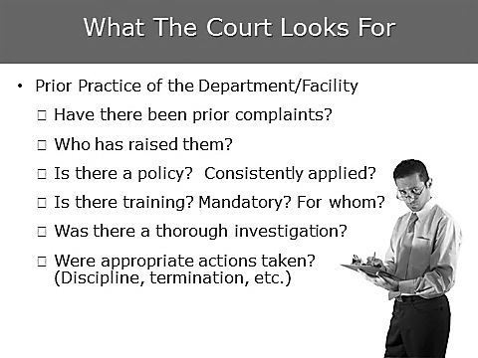  The court looks at:  - Past behaviors and past complaints  - Investigations to see if allegations were appropriately addressed and if responses were adequate.  As an investigator, look for patterns of incidents, high risk situations, or facility weaknesses that exist and ensure administrators are aware of these so that they can be addressed. | What The Court Looks For
.5 min | Staff Sexual Misconduct Criminal Laws  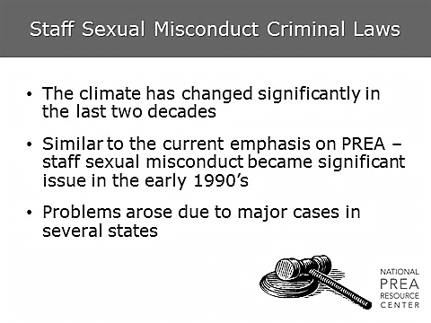  - Criminal law has changed significantly over time. In the 1990s, several significant lawsuits raised national awareness around the issue of staff sexual misconduct.  - This attention resulted in an increase in state criminal laws addressing staff sexual misconduct and, eventually, the Prison Rape Elimination Act. | Staff Sexual Misconduct Criminal Laws
.5 min | Staff Sexual Misconduct Criminal Laws  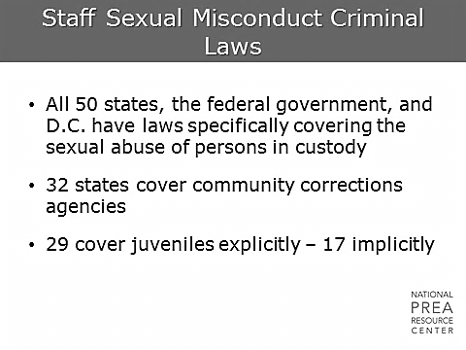  Now, all 50 states and the federal government have laws that specifically cover the issue of sexual abuse of people in custody. | Staff Sexual Misconduct Criminal Laws
.5 min | 1990 State Laws Prohibiting Staff Sexual Abuse  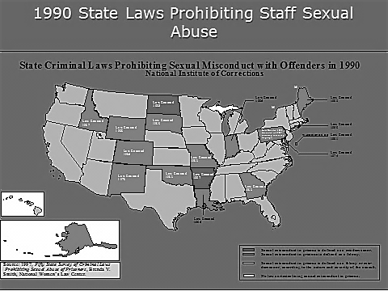  In 1990, less than half the states had laws addressing the sexual abuse of people in custody. | 1990 State Laws
.5 min | 2010 State Laws Prohibiting Staff Sexual Abuse  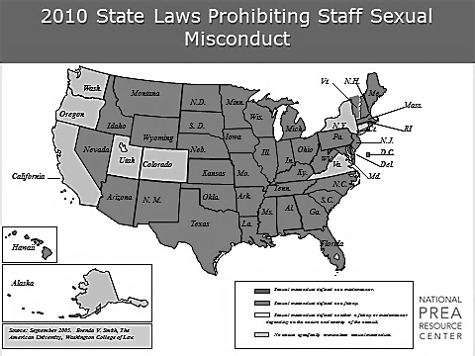  It wasn’t until 2010 that all states had laws addressing the issue, including laws covering community corrections either implicitly or explicitly. | 2010 State Laws
.5 min | States that Cover Community Corrections 2010  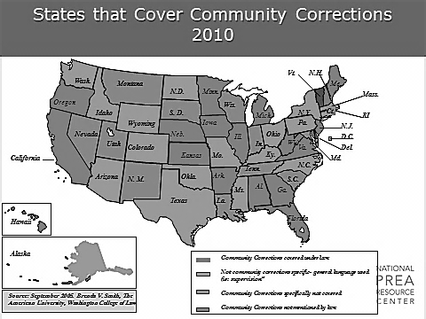  These last two maps demonstrate how sexual abuse in correctional settings has become more acknowledged and addressed through legislation.  State laws address sexual abuse in community corrections … | States that Cover Community Corrections
.5 min | States that Cover Juvenile Justice Agencies  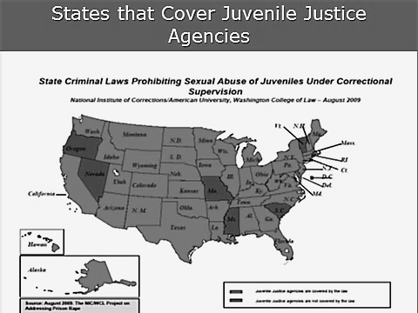  …and juvenile justice agencies. | States that Cover Juvenile Justice
1 min |  | Insert slide with the laws of the state in which your agency/facility is located.
1 min | Other State Criminal Laws  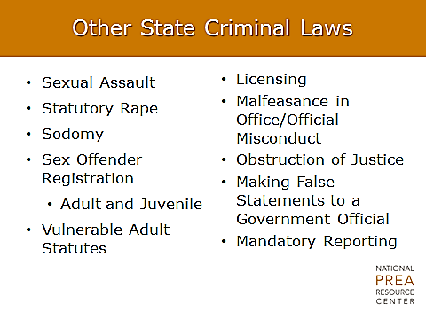  Here is a list of some of the laws that investigators and prosecutors may use in a case.  Some staff members who have been involved sexually with an inmate may think that termination is a possible consequence of their actions. They may be surprised to learn that they could also be sentenced to time in prison and/or have to register as a sex offender for the rest of their lives. | Other State Criminal Laws
1 min | State Tort Law Claims  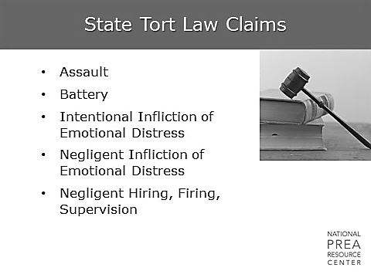  What is tort?  - Tort is a civil claim for money. It is usually a claim additional to the criminal charge, and an additional liability to the agency and the individual. | State Tort Law Claims  Ask the class to define tort and wait for an answer before moving on.
1 min | Litigation  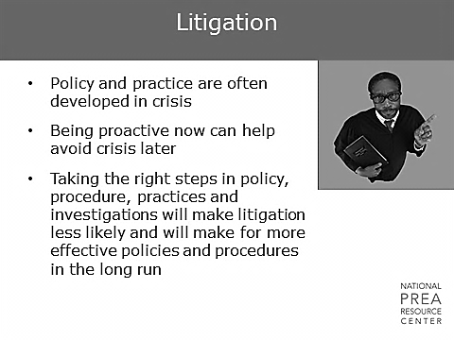  As an investigator, you have access to information about your agency that other people do not. Be aware of how that information can guide the development and revision of policy and practice.  Do not be afraid to speak up when you see policies or practices that need to be developed or modified that could help minimize your agency’s exposure and liability. | Litigation
1 min | PREA and Legal Issues  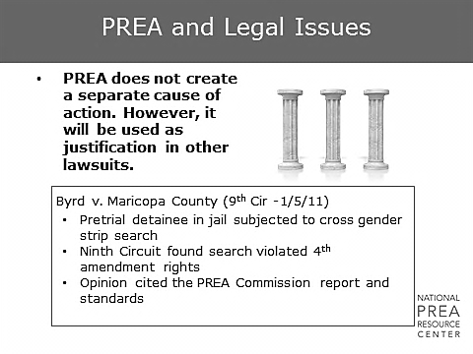  Is there such a thing as a PREA lawsuit? No. PREA does not create a new cause of action.  However, this doesn’t mean you cannot file a lawsuit based on another cause of action and allege that the agency/facility is not compliant with PREA. For example, PREA was used as additional support in this case for damages and liability.  The most common bases for legal challenges are:  - 42 U.S. C. 1983  - Eighth Amendment  - Fourth Amendment  - Fourteenth Amendment  - State tort claims | PREA and Legal Issues  Ask the class whether there is such a thing as a PREA lawsuit and wait for some answers before moving on.
1 min | Legal Framework  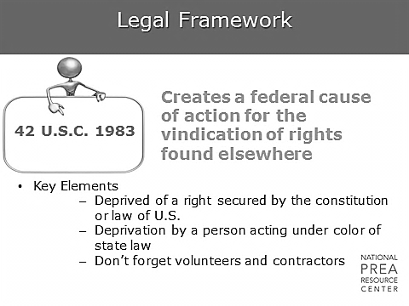  This means, if an inmate’s rights under the Constitution or federal law are violated, they can use this legal framework to sue. Why would a plaintiff want to take a case to a federal (vs. state) court? Because it removes the “home court” advantage of the agency from their state where they may have relationships. | Legal Framework
1 min | Official Liability: 8th Amendment  Farmer v. Brennan, 511 U.S. 825 (1994)  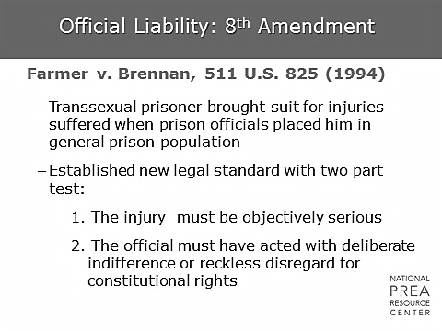  The 8th Amendment prohibits cruel and unusual punishment.  Farmer v. Brennan is one of the more famous 8th Amendment lawsuits because it established the legal standard of deliberate indifference.  - This case was brought against the Federal Bureau of Prisons by a prisoner who was sexually abused while in custody.  - The plaintiff argued that prison officials should have known that he would be hurt in the general population because he was transsexual, and therefore staff should have protected him.  - He sued on the basis that his 8th Amendment right was violated.  - The deliberate indifference legal standard has a two part test.  - Was the injury objectively serious?  - What does “objectively” mean?  - It means that it can be demonstrated through some sort of evidence, e.g., medical records, expert testimony, pictures.  - Can you have an objectively serious mental health injury? Yes.  - Did the official act with deliberate indifference or reckless disregard for the offender’s constitutional rights? | Official Liability: 8th Amendment  Ask the class the following questions and wait for answers. Encourage discussion.  Ask: What does deliberate indifference mean?  Ask: What does “objective” mean?
1 min | 8th Amendment: What the Court Looks For  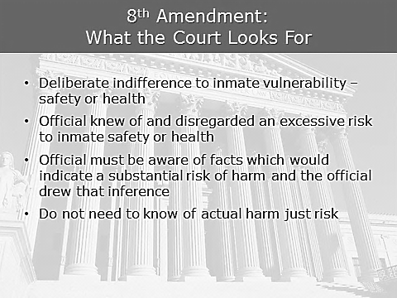  Deliberate indifference means that the official wantonly disregarded knowledge that he/she had or that he/she should have known.  - The court looks to see whether officials demonstrated a deliberate indifference to some risk factor, either to the inmate’s safety or health.  - This would mean that the official knew of and disregarded an excessive risk to inmate/resident safety or health, or that the official was aware of facts that indicated a substantial risk of harm and that the official drew that inference.  - It’s important to note that the official does not need to know of any actual harm, but just be aware of the risk of harm. | 8th Amendment: What the Court Looks For
1 min | Legal Framework  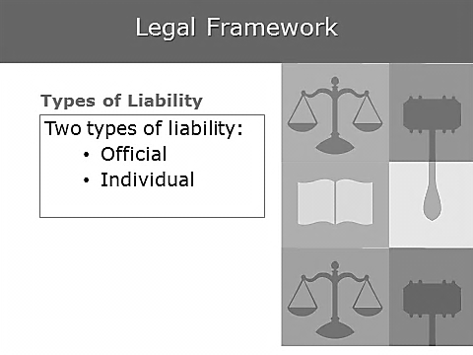  There are two types of liability.  - What is official liability? It is agency liability or liability within your official capacity.  - Individual liability is personal. If it is found that you are liable, you pay. | Legal Framework
1 min | Legal Framework  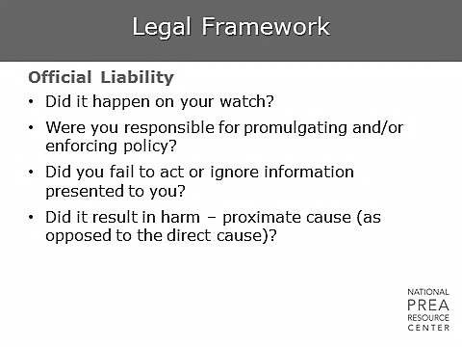  The question that is asked here is: What information did you have? Can you be held officially liable if you were not directly involved? Yes – through proximate cause. | Legal Framework
1 min | Legal Framework  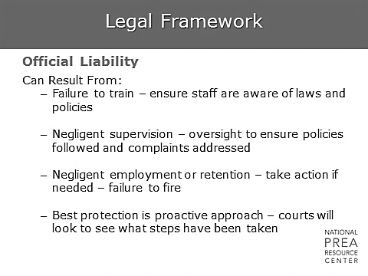  This can result from your hiring someone who was not appropriately vetted or keeping someone employed who should have been fired.  - Some administrators will avoid firing someone so as to avoid being sued. It is better to be sued for firing someone than to be blamed in the event that you did not fire that individual, and they perpetrated sexual abuse.  - The way to mitigate official liability is to pay attention to patterns or “red flags” and to be proactive rather than reactive.  - The more proactive you are and the more you follow personnel policies and the law, the less official liability there will be. | Legal Framework
1 min | Legal Framework  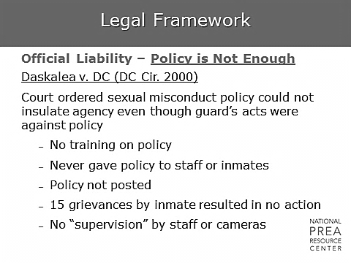  Policy is not enough. This agency had a great policy but they never trained on it.  - Having a policy in writing is a good start, but staff, contractors, and volunteers need to be trained on it. Minimally, they need to read it and sign it, showing it has been read and understood.  - Policy is not helpful unless something is done with it. | Legal Framework
1 min | Legal Framework  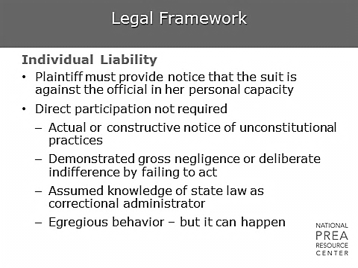  - Usually, if you are sued, you are sued in your official capacity.  - There is a pretty high standard for a finding of individual liability. | Legal Framework
1 min | Riley v. Olk-Long, 282 F.3rd 592 (8th Cir. 2002)  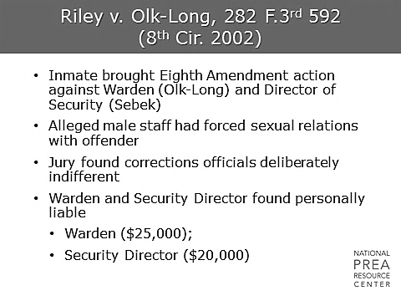  - This case is out of Iowa and is a lawsuit against a warden and security director at a women’s facility.  - They were sued in both their official and individual capacity and were found liable. The decision was upheld on appeal in 2002. | Riley v. Olk-Long
1 min | Riley v. Olk-Long – What Happened?  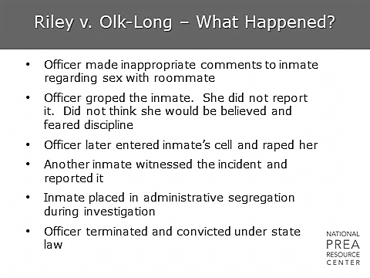  What happened?  - A new inmate came into the facility, and a male officer started harassing her.  - He started off with jokes about her having a lesbian relationship with her roommate. When she did not object to the jokes, he groped her and then waited to see what she did.  - When she did not report his behavior, he raped her.  - She also did not report the rape. However, there are no secrets in prison, and the rape became known and was reported by another inmate.  So, why are the security director and the warden being held responsible? | Riley v. Olk-Long
1 min | Riley v. Olk-Long Why Personal Liability?  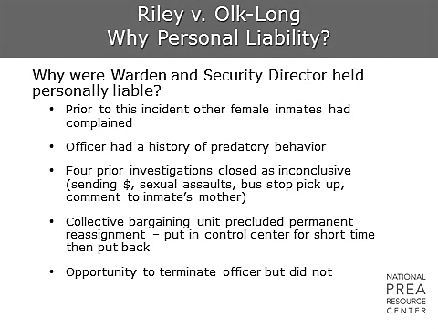  - There had been previous complaints about the officer’s past behavior.  - It is debatable whether there was enough evidence in the past to fire him, but there had been a number of (mostly inconclusive) investigations.  - The problem was that a collective bargaining agreement required the facility to move someone under investigation only for a specific and limited period of time.  - So, despite the fact that the officer was actually under investigation at the time of the sexual abuse, he continued to work in the housing unit. | Riley v. Olk-Long
1 min | Riley v. Olk-Long – Court Decision  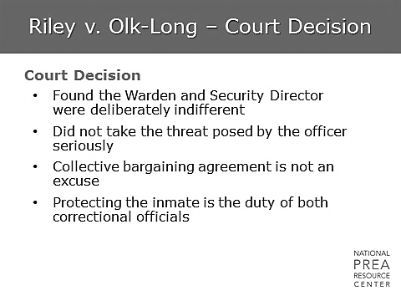  The court found that:  - The officer should have been fired or kept away from the inmates.  - A collective bargaining agreement is not an excuse. You cannot bargain away someone’s constitutional rights.  - If the officer was constantly under investigation without allegations ever being substantiated, there might be a problem with the investigation process. | Riley v. Olk-Long
1 min | Ortiz v. Jordan (S.CT. 1/24/11)  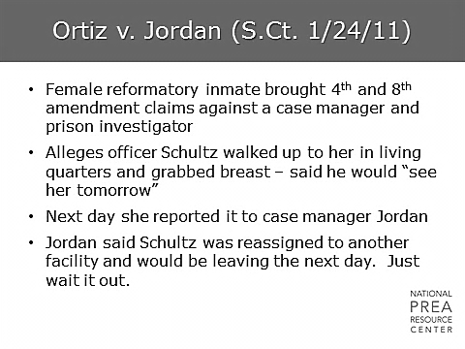  The female inmate in this case brought both a 4th Amendment and 8th Amendment claim against the agency. What happened?  - The inmate was groped and reported the incident.  - Instead of reporting it and removing the inmate from contact with the officer, her case manager told her that it was the officer’s last day and that she should wait it out.  - The inmate was sexually assaulted later that same day. | Ortiz v. Jordan
1 min | Ortiz v. Jordan (S.CT. 1/24/11)  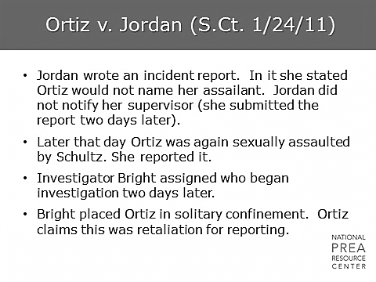  - After the assault, the case manager waited two days to write an incident report and falsely stated that the inmate would not name the perpetrator.  - The investigation was also unnecessarily delayed and did not start until two days after the incident.  - Once the investigation began, the inmate was put in solitary confinement, which was seen as retaliatory since she had been in general population for two days after the incident without problems. | Ortiz v. Jordan
1 min | Ortiz v. Jordan (S.CT. 1/24/11)  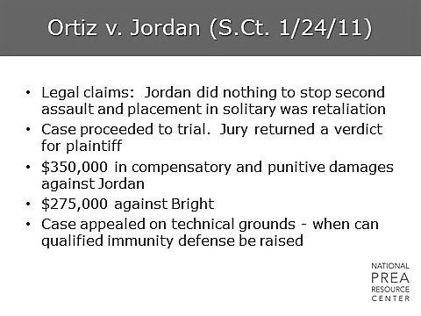  The verdict returned by the jury held both the case manager and the investigator personally liable. | Ortiz v. Jordan
1 min | Gonzales v. Martinez, 403 F.3d 1179 (10th Cir. 2005)  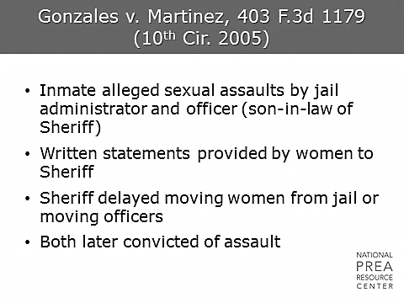  This case addresses what top administrators should know.  - A sheriff’s son-in-law had a number of allegations made against him. The sheriff did not respond appropriately and was held accountable. | Gonzales v. Martinez
1 min | Gonzales v. Martinez –  Court Findings  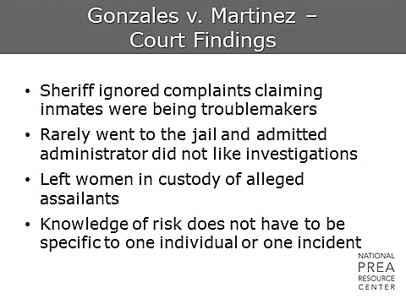  Why was he held accountable?  - It was found that the sheriff should have known what was going on.  - Rather than investigating the allegations, he ignored the cases and failed to remove the women from contact with their alleged assailants.  - The son-in-law was later convicted of assault.  - Although all agencies have complaints by troublemakers, all allegations have to be investigated, or the agencies and the individuals within the agency can be held liable. | Gonzales v. Martinez
1 min | Beers-Capitol v. Whetzel, 256 F.3d 120 (2001)  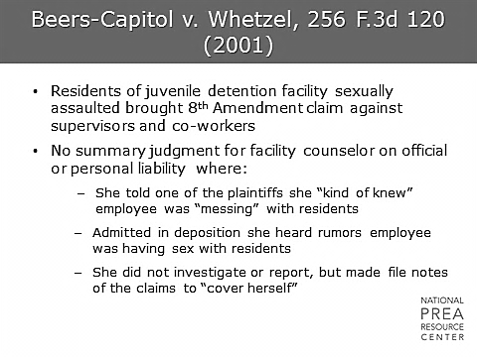  This was a highly visible case in the media with significant liability.  - The juveniles made an 8th Amendment claim of sexual assault and tried to claim summary judgment.  - This would mean that, assuming all of the allegations are true, the plaintiffs would win.  - Here, the counselor made two mistakes.  - She admitted to suspecting something without reporting it.  - She documented her suspicions.  What do we tell our staff about reporting?  - It is easy to report when someone approaches you with an allegation. But what about rumors? Suspicion?  - It is best to over-report rather than under-report. Do not put your own career on the line for someone else. | Beers-Capitol v. Whetzel
1 min | Guidry v. Rapides School Board, 560 So.2d 125 (La. App. 1990)  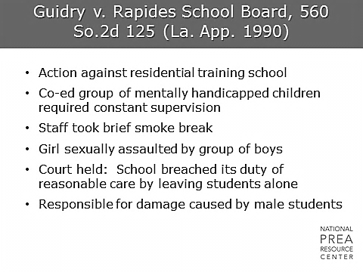  - In this case, a staff member left a group of mentally handicapped children alone during a brief smoke break.  - During this time, a girl was sexually assaulted by a group of boys.  - The court determined that the staff member breached his duty by leaving the youth alone, and was therefore held liable.  - This is a general supervisory lesson: Vulnerable individuals require supervision at all times. | Guidry v. Rapides School Board
1 min | R.G. v. Koller (D. Hawaii 2006)  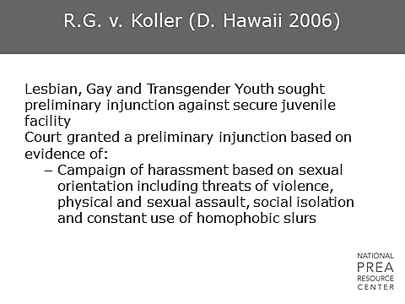  - In this case, three juveniles (one male-to-female transgender youth, one lesbian, and one 18-year-old boy perceived to be gay) sued Hawaii Youth Correctional Facility for harassment and extensive use of isolation. | R.G. v. Koller (D. Hawaii 2006)
1 min | R.G. v. Koller  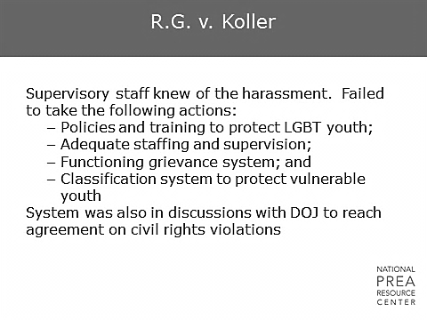  - The facility claimed the isolation was reasonable and non-punitive. The court determined that the use of isolation on children was not within the “range of accepted professional practices” and constituted punishment in violation of due process rights.”  - The court maintained the facility was deliberately indifferent based on its lack of:  - Policies and training necessary to protect LGBT youth;  - Adequate staffing and supervision;  - A functioning grievance system; and  - A classification system to protect vulnerable youth.  - The court also criticized the agency for using isolation as their first option and having no alternative housing plan. | R.G. v. Koller
1 min | Kahle v. Leonard (8th Cir. 2007)  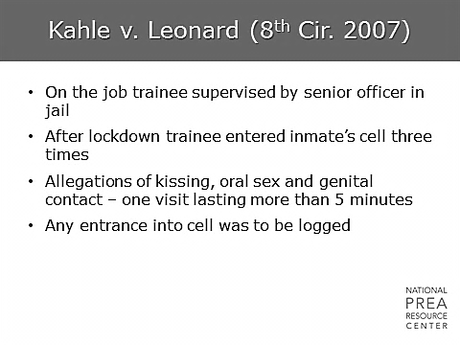  This is a case about supervisors, new staff, turnover in staff, and technology.  - Within this facility, policy required logging every entrance to a cell. However, a trainee under supervision by an experienced officer entered an inmate’s cell multiple times within one evening with no justification or logging of the entrance and sexually abused her each time. | Kahle v. Leonard
1 min | Kahle v. Leonard (8th Cir. 2007)  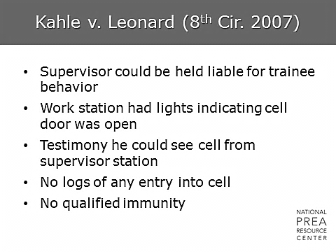  - The experienced officer who was training the new employee was sitting at a workstation.  - From that work station, he could clearly see a board on which a light comes on every time someone enters a cell.  - Additionally, he could actually see the cell itself from his seat. Therefore, it was determined that the supervisor could be held liable for the trainee’s behavior. | Kahle v. Leonard
1 min | Legal Framework  Qualified Immunity  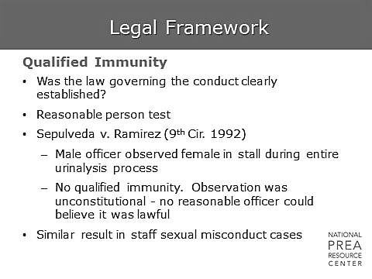  Qualified immunity allows government employees to take advantage of a legal framework wherein their responsibilities are not clearly defined. If the law is not clear enough, the individual should not be penalized for a reasonable interpretation of the law. This applies only to government employees, not private employees. In this case,  - A male staff member observed a female throughout the entire urinalysis process.  - He attempted to claim qualified immunity.  - Because laws governing cross-gender supervision during a urinalysis are clearly defined, he was not determined to have qualified immunity.  Sexual abuse laws are also very clearly defined now, so it is difficult to argue for qualified immunity in these sorts of cases. | Legal Framework
1 min | Volunteer and Contractor Liability  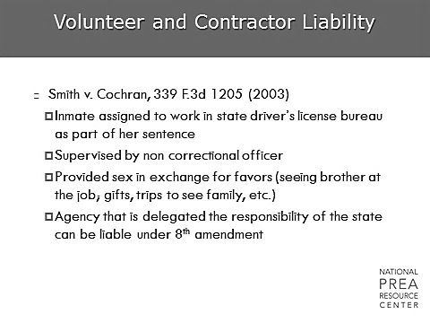  Volunteers and contractors can be helpful in a facility but also can create additional exposure to liability.  This is a case where a love affair between a male supervisor (contractor) at a state driver’s license bureau and the female inmate working for him ended, and the inmate sued.  Who is liable, the Department of Corrections (DOC) or the Drivers License Bureau? The answer here is the DOC, because they gave authority over the inmate to the contractor and did not appropriately train him. | Volunteer and Contractor Liability
1 min | Volunteer and Contractor Liability  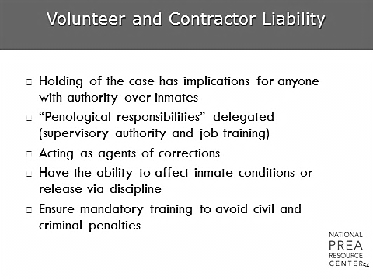  What if the contractor had been appropriately trained?  - This probably would have protected them against liability.  - There was another case with a privately-contracted drug treatment counselor who sexually abused an inmate. The inmate sued, but the agency could demonstrate that they had policy and training in place and that the contractor had no history of this sort of behavior.  - The DOC could show that they had done their best to prevent the incident and were not liable. | Volunteer and Contractor Liability
1 min | Investigative Process  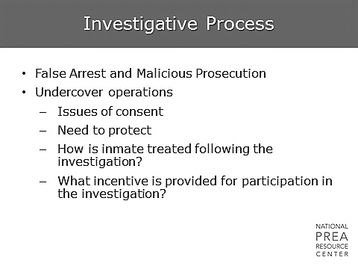  - Within the investigative process, an agency can be sued in a number of different ways. An agency and investigator can be sued for false arrest or malicious prosecution if a defendant can demonstrate that the investigation was poorly done and did not provide enough evidence to arrest or prosecute.  - Additionally, there are a number of issues involved with undercover operations. When covertly monitoring staff, investigators need to be sure that staff could not argue there was a reasonable expectation of privacy.  - If an inmate participates, retaliation needs to be monitored for and prevented. Additionally, investigators need to make sure the incentives they use to convince an inmate to participate are appropriate.  - Finally, if there was enough evidence to move forward with a prosecution but the agency chose not to proceed, this could create liability for both the investigator and the agency. | Investigative Process
1 min | Investigative Process: Corona v. Lunn, 2002 WL 550963 (S.D.N.Y April 11, 2002)  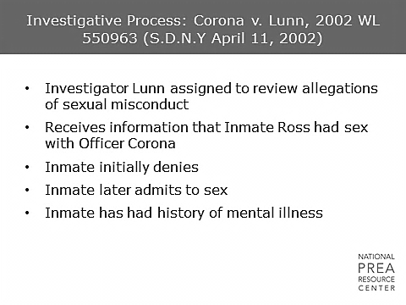  Here is an example of a case where an investigator was sued for false arrest and malicious prosecution.  - An allegation was made that an inmate with a history of mental illness was sexually abused by an officer.  - When interviewed, the inmate initially denies it, but later states that sex did occur. | Investigative Process
1 min | Investigative Process: Corona v. Lunn, 2002 WL 550963 (S.D.N.Y April 11, 2002)  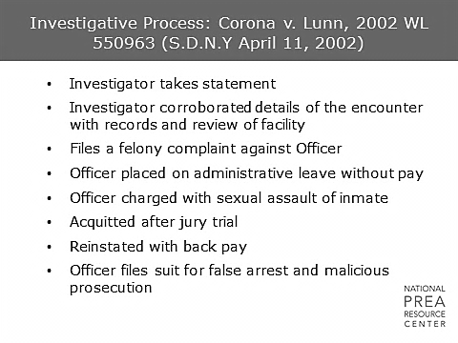  The investigator corroborated some details provided by the inmate and filed a felony case against the officer. After a jury trial, the officer was acquitted and reinstated with back pay. He then sued for false arrest and malicious prosecution. | Investigative Process
1 min | Investigative Process Standards  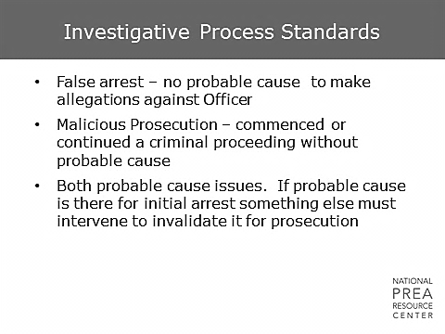  A false arrest requires there to be no probable cause to make allegations against the defendant. Malicious prosecution is the commencement or continuation of criminal proceedings without probable cause.  Normally, if there is probable cause for arrest, there is probable cause for prosecution, so a malicious prosecution claim would require some additional evidence to have surfaced if it were to be made in isolation. | Investigative Process Standards
1 min | Investigative Process: Corona v. Lunn, 2002 WL 550963 (S.D.N.Y April 11, 2002)  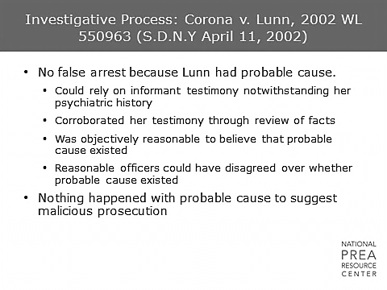  - In this case, it was determined that the investigator had probable cause. An informant’s mental health history does not delegitimize his/her testimony. Additionally, the investigator corroborated the inmate’s testimony in other ways.  - This meets the standard: It was objectively reasonable to believe that probable cause existed. This also means that two reasonable investigators could disagree over whether probable cause existed.  - The malicious prosecution claim was not upheld because probable cause was found for the initial arrest, and no new evidence had surfaced before the prosecution. | Investigative Process
1 min | Sting Operations: Sanchez-Luna v. U.S. (Dec. 2004)  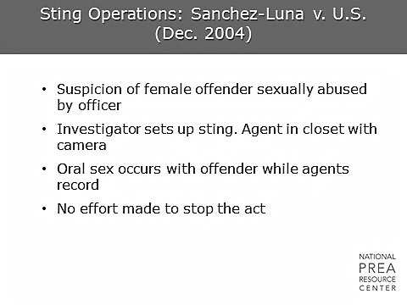  Sting operations are also areas of potential liability.  - In this case, they used a female offender to catch an officer in the act of sexual abuse.  - The female offender cooperated with the investigation, and the officer incriminated himself. The problem here is that instead of just videotaping the mandatory minimum amount of activity, the camera kept rolling and investigators did not stop the abuse. | Sting Operations
1 min | Result of Litigation: Sanchez-Luna v. U.S. (Dec. 2004)  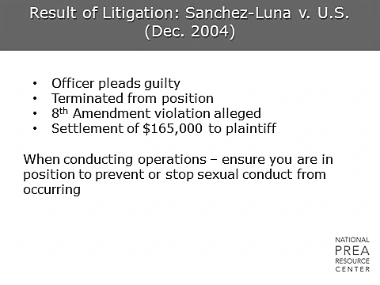  - So, the inmate sues.  - The point here is that the minute you start to see the incriminating behavior, you have enough evidence and can stop filming. | Result of Litigation
1 min | Elements of Failure to Protect  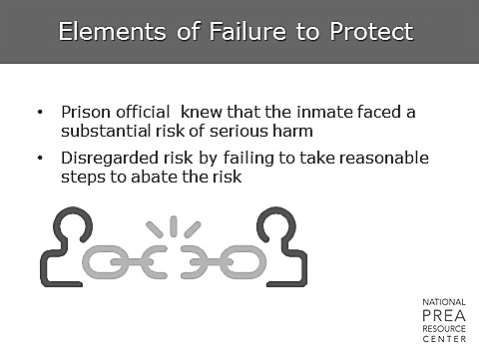  Failure to protect is an important claim within corrections. It requires that a facility official knows that an inmate faces a substantial risk of serious harm, but fails to take reasonable steps to protect him or her. | Elements of Failure to Protect
1 min | Failure to Protect: Brown v. Scott, 329 F.Supp.2d 905 (E.D. Mich. 2004)  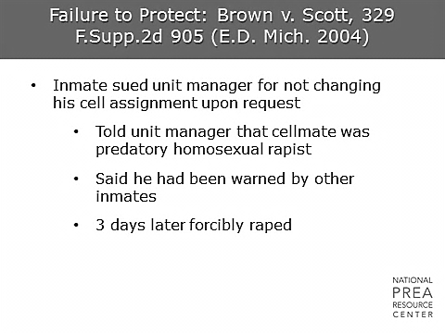  This is a case in Michigan where an inmate went to his unit manager and said, “Look, I’ve been told that my cellmate is a predatory homosexual rapist.” However, nothing was done to protect the inmate, and he was raped three days later. | Failure to Protect
1 min | Failure to Protect: Brown v. Scott, 329 F.Supp.2d 905 (E.D. Mich. 2004)  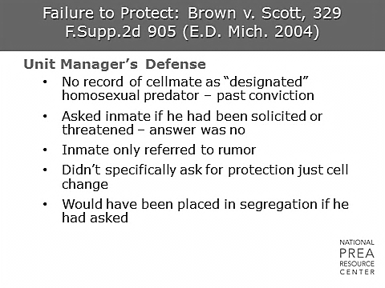  - The defense for the case was that the cellmate was not designated as a “predator” because he did not have a conviction.  - The unit manager asked the inmate if he had been threatened, and he said no. The inmate also did not ask for protection, just for a cell change.  - Why do you think that was? Because he did not want to go to segregation. | Failure to Protect
1 min | Failure to Protect: Brown v. Scott, 329 F.Supp.2d 905 (E.D. Mich. 2004)  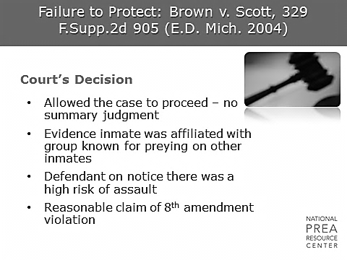  - The court determined that there would be no summary judgment and allowed the case to proceed. Soon thereafter, more information was revealed. The cellmate was part of a group of inmates known for predatory behavior, and the inmate’s case manager was not informed of the inmate’s concern.  - What sort of information should be shared across the facility? What kinds of screening tools should be used when making housing placements? | Failure to Protect
1 min | The 4th Amendment  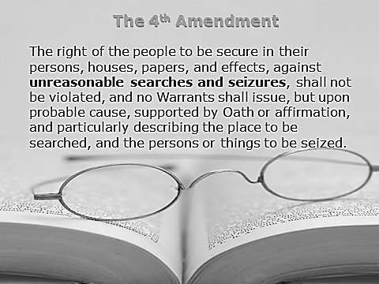  Another right to be aware of when conducting investigations is the right of your staff against unreasonable searches and seizures.  - You need to consider this when deciding whether to search a staff person’s locker or car or to record one of their conversations.  - If there is signage informing the staff that cars in the facility parking lot are subject to search, that lockers within the facility are subject to search, and that phone conversations made from within the facility are subject to recording, then you can make the argument that there was no reasonable expectation of privacy.  - However, if those signs are not in place, and there has been no training on this topic, you’ll have to be careful. Consult with legal. Ensure you get a warrant or other appropriate permission before doing anything that may contaminate evidence or inhibit prosecution. | The 4th Amendment
1 min | Privacy  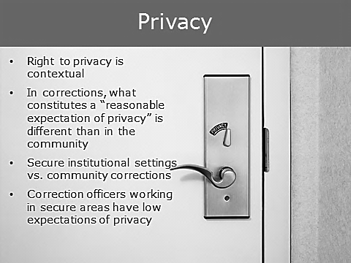  Correctional investigators do have an advantage — privacy is different in the institutional context for both inmates and staff. If handled correctly, investigators can have access to these sorts of searches. In addition, “searches” is a broad term that could apply to cameras, cars, purses or cells. | Privacy
1 min | Surveillance  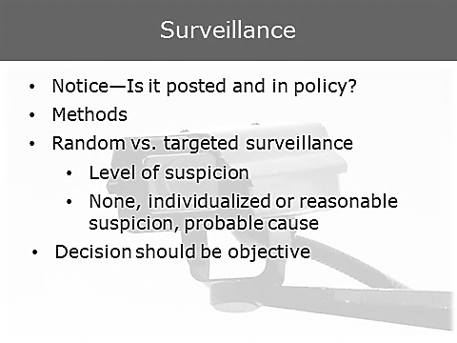  Similarly, it is important to give notice if surveillance is possible. | Surveillance  Insert agency policy regarding surveillance.
1 min | Employee Surveillance  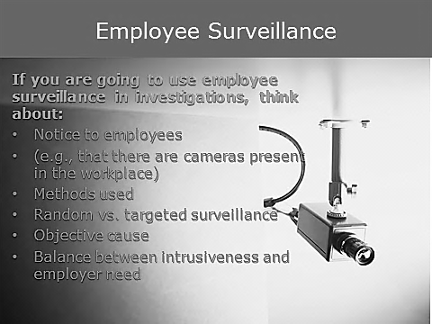  - Consider whether notice has been given to employees when deciding what methods to use.  - Establish how best to balance your employees’ rights with your need for information and safety. | Employee Surveillance
10 min | Activity: Scenario |   Divide participants into groups of four and have them answer the questions in this scenario. Have one group volunteer to present their answers to the class for discussion. They will have six minutes to work on it and four minutes to report out.  Refer to “Module 2 Legal Issues and Agency Liability” attachment.
1 min | Lessons Learned: Liability  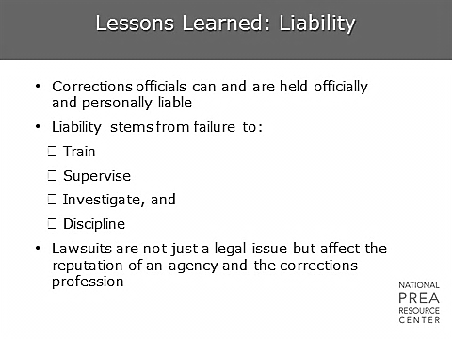  As we mentioned earlier, as an investigator, you have access to information about the agency that many others do not. This information can be used to influence the policies, practice, and leadership of the agency. | Lessons Learned
1 min | Lessons Learned: Liability  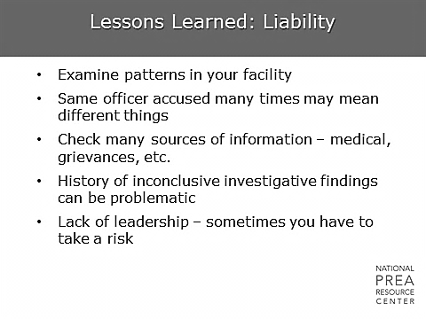  Examine the patterns that appear throughout your investigations.  - What officers are consistently involved in allegations?  - What areas of facilities are hot spots? Keep administrators in the loop. | Lessons Learned
1 min | Questions?

