Module 4: Trauma and Victim Responses: Considerations for the Investigative Process

Time: 2:00 p.m. – 3:00 p.m. (1 hour)

Training Objectives:
- Understand the short and long term impact of trauma on victims.
- Identify how trauma can affect a victim’s cooperation in an investigation.
- Learn how an investigator can facilitate a victim’s willingness to cooperate with an investigation.

Materials Needed:
- Easel pad and markers
- PowerPoint® player/machine (laptop computer and LCD projector)
- Screen or monitor
- Handout: Scenario “Module 4 Handout 1”

Training Tips:
- This module is intended to help investigators understand why being informed about the effects of trauma on victims will help them conduct more thorough investigations.
- Throughout the training, emphasize that a victim’s responses to trauma are not impacted by their status as an offender – they are not less traumatized because of their criminal history. Therefore, it is very important for investigators to understand how sexual abuse victims react and to adjust their approaches accordingly.
- It would be helpful for the trainer to enlist the support of a medical or mental health professional who is educated on the effects of trauma and the responses of sexual abuse victims, either in preparation or in the delivery of the module.
- Be advised that this module may contain material that utilizes concepts and language that may be upsetting or difficult for some participants. This may include statements referring to genitalia, sexual harassment, sexual abuse, trauma, and suicide. Videos used may also contain profanity. Please review all materials prior to using to ensure they are appropriate for use in your agency and make substitutions where needed. You should also consider providing a general notice to participants at the beginning of each training session.

- Please note that this module was developed specifically for facilities that use the Adult Prisons and Jail or Juvenile PREA Standards. Facilities using the Community Confinement or Lockup standards should review all standard references to ensure that the content and language is appropriate for their facility type and inmate/resident population and adjust the material as needed to their specific circumstance.

Time | Lecture Notes | Teaching Tips
 | Trauma and Victim Responses:  Consideration for the Investigative Process | 
1 min | Objectives  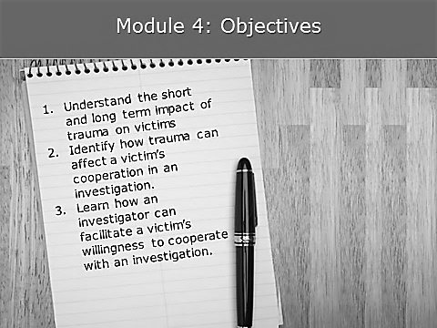 | Objectives
1 min | What Does Being  “Trauma Informed” Mean?  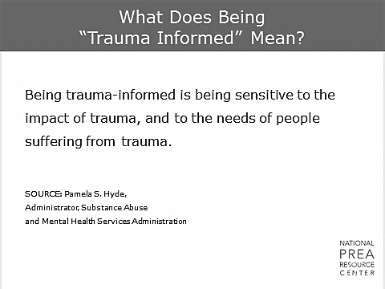  Being trauma-informed is  - Being sensitive to the impact of trauma and to the needs of people suffering from trauma.  - Extremely important when dealing with victims of sexual abuse. | What Does Being  “Trauma Informed” Mean?  SOURCE: Pamela S. Hyde,  Administrator, Substance Abuse and Mental Health Services Administration
1 min | Why Does Trauma Matter?  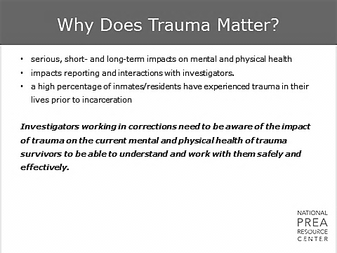  Investigators working in corrections need to be aware of the impact of trauma on the mental and physical health of trauma survivors in order to understand and work with them safely and effectively.  - Trauma has very serious, short- and long-term impacts on the mental and physical health of men and women.  - Victims of sexual abuse have experienced highly traumatic events that may impact how and when they report and their subsequent interactions with investigators.  - A high percentage of inmates have experienced trauma (sexual, physical and emotional) in their lives prior to incarceration, which may have an impact on their perceptions of others and of you.  This will be important to remember both in investigating incidents of sexual abuse and in working with inmates/residents generally.
15 min | Why Does Trauma Matter?  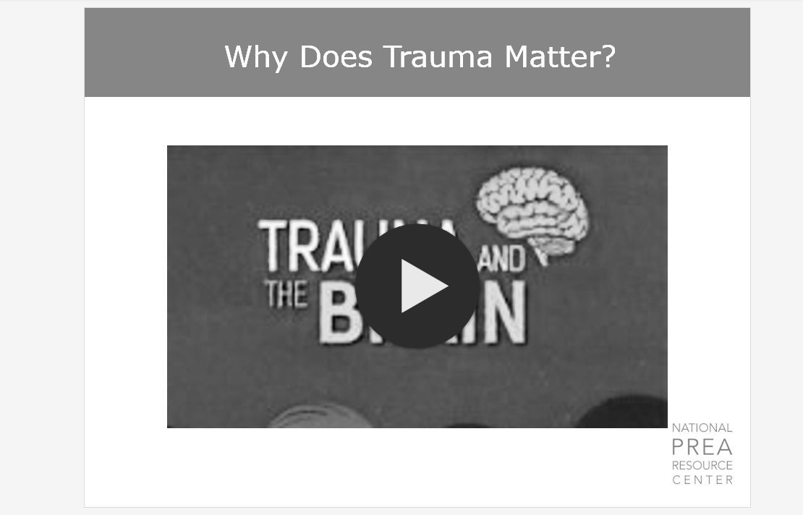 | Why Does Trauma Matter?    Video link: https://www.youtube.com/watch?v=4-tcKYx24aA  This video provides insight into understanding trauma on the brain. Inmates might have limited responses and memory related to their trauma. This video is to help you understand the effects of abuse.
1 min | Neurobiology of Trauma  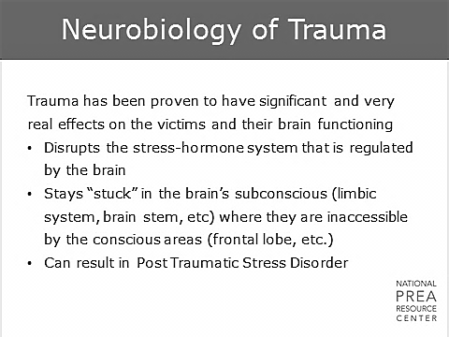  The ACE findings are also applicable to trauma experienced later in life. The biological impact of trauma on the brain is demonstrable and long-lasting. An experience that is perceived by the victim to be life-threatening will disrupt the stress-hormone system of the brain.  - Traumatic events stay “stuck” in the brain’s subconscious (limbic system, brain stem, etc.) where they are inaccessible by the conscious areas (frontal lobe, etc.)  - Trauma can result in Post Traumatic Stress Disorder (PTSD)
1 min | Neurobiology of Trauma  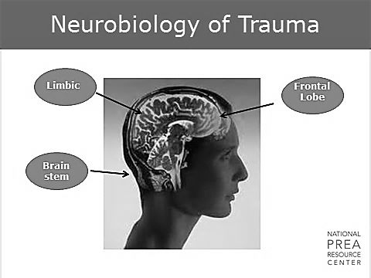  We’re going to briefly discuss how that works. Here’s an image of the brain to give you an idea of what we’re talking about. The frontal lobe is shown here in red, the limbic system is shown in blue, and the brain stem is shown in yellow.
1 min | Trauma and the Brain  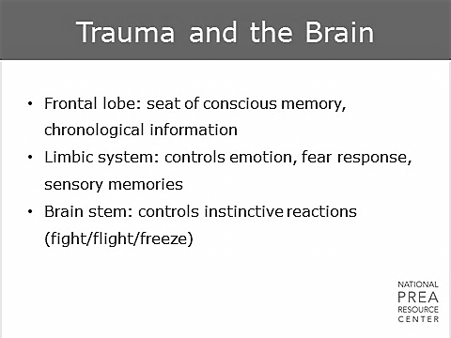  - Frontal lobe: seat of conscious brain. Controls memory, chronological information  - Limbic system: controls emotion, fear response, sensory memories  - Brain stem: controls instinctive reactions (fight/flight/freeze)
2 min | Limbic System    Let’s talk about two parts of the limbic system.  - Amygdala: small region of the limbic system that plays a primary role in the formation and storage of memories associated with emotional events.  - It is also where the response to those emotions starts: increase in heart rate, respiration, and stress-hormone release.  - Trauma can cause the amygdala to become hypersensitive and trigger those responses to normal stimuli. Reminders of trauma can also spark that reaction.  - Hippocampus: processes all conscious memory.  - Highly sensitive to the stress-hormones released by the amygdala.  This means that when the amygdala is active, it interferes with the victim’s ability to remember events.
2 min | Frontal Lobe  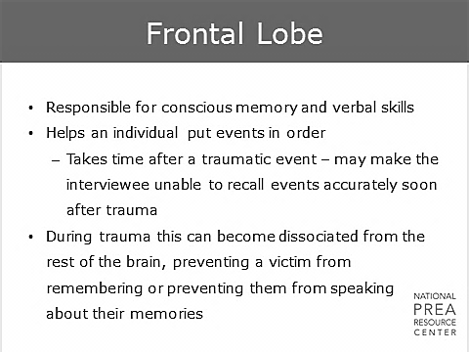  Similarly, the frontal lobe may  - Become dissociated from the rest of the brain during times of trauma  - Need time after a traumatic event to accurately recall events. If that time is not allowed, a victim may have trouble remembering or speaking about the events.  For example, if an officer is assaulted by an offender and reacts as trained, he/she:  - May not have much memory of his/her actions.  - May remember the initial assault and defense, but  - May not remember striking the offender five times after that.
3 min | Trauma and the Brain: What does this mean for investigators?  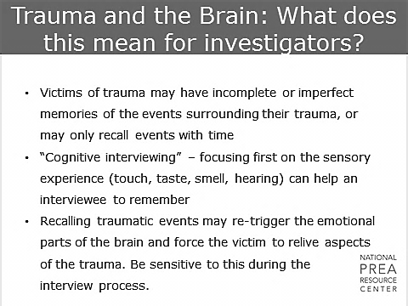  So, if the amygdala depresses the functioning of the hippocampus during a traumatic event, this will impede a victim’s ability to remember what happened or the chronology of those events. As an investigator, it is important to recognize that  - A victim who is unable to clearly remember an incident of sexual abuse may be suffering from the impact of trauma.  - Focusing on questions concerning sensory memories (i.e., sight, smell, hearing) may be more effective than questions on chronology of events  - A reminder of the trauma may re-trigger these processes, forcing the victim to re-live aspects of the trauma.  Avoid repetitive interviews where the victim is required to repeat their account of events. You should also provide victims with the time they need to fully communicate their information. A victim advocate may also assist in this.
1 min | Implications: How to be Trauma Informed  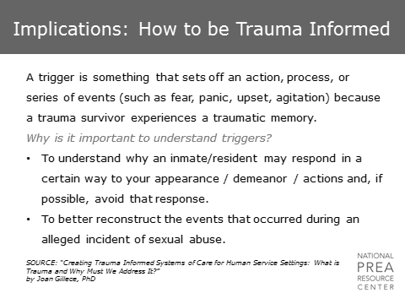  A trigger is something that sets off an action, process, or series of events. It reminds the victim of his/her trauma and sets off a flashback or intense feeling of fear, panic or agitation. You can trigger a victim by something you say, something you do or even by your appearance.  Why is it important to understand triggers?  - To understand why an inmate/resident may respond in a certain way to your appearance/demeanor/actions and, if possible, avoid that response.  - To better reconstruct the events that occurred during an alleged incident of sexual abuse. | SOURCE: “Creating Trauma Informed Systems of Care for Human Service Settings: What is Trauma and Why Must We Address It?”  by Joan Gillece, PhD
6 min | Trauma and the Brain  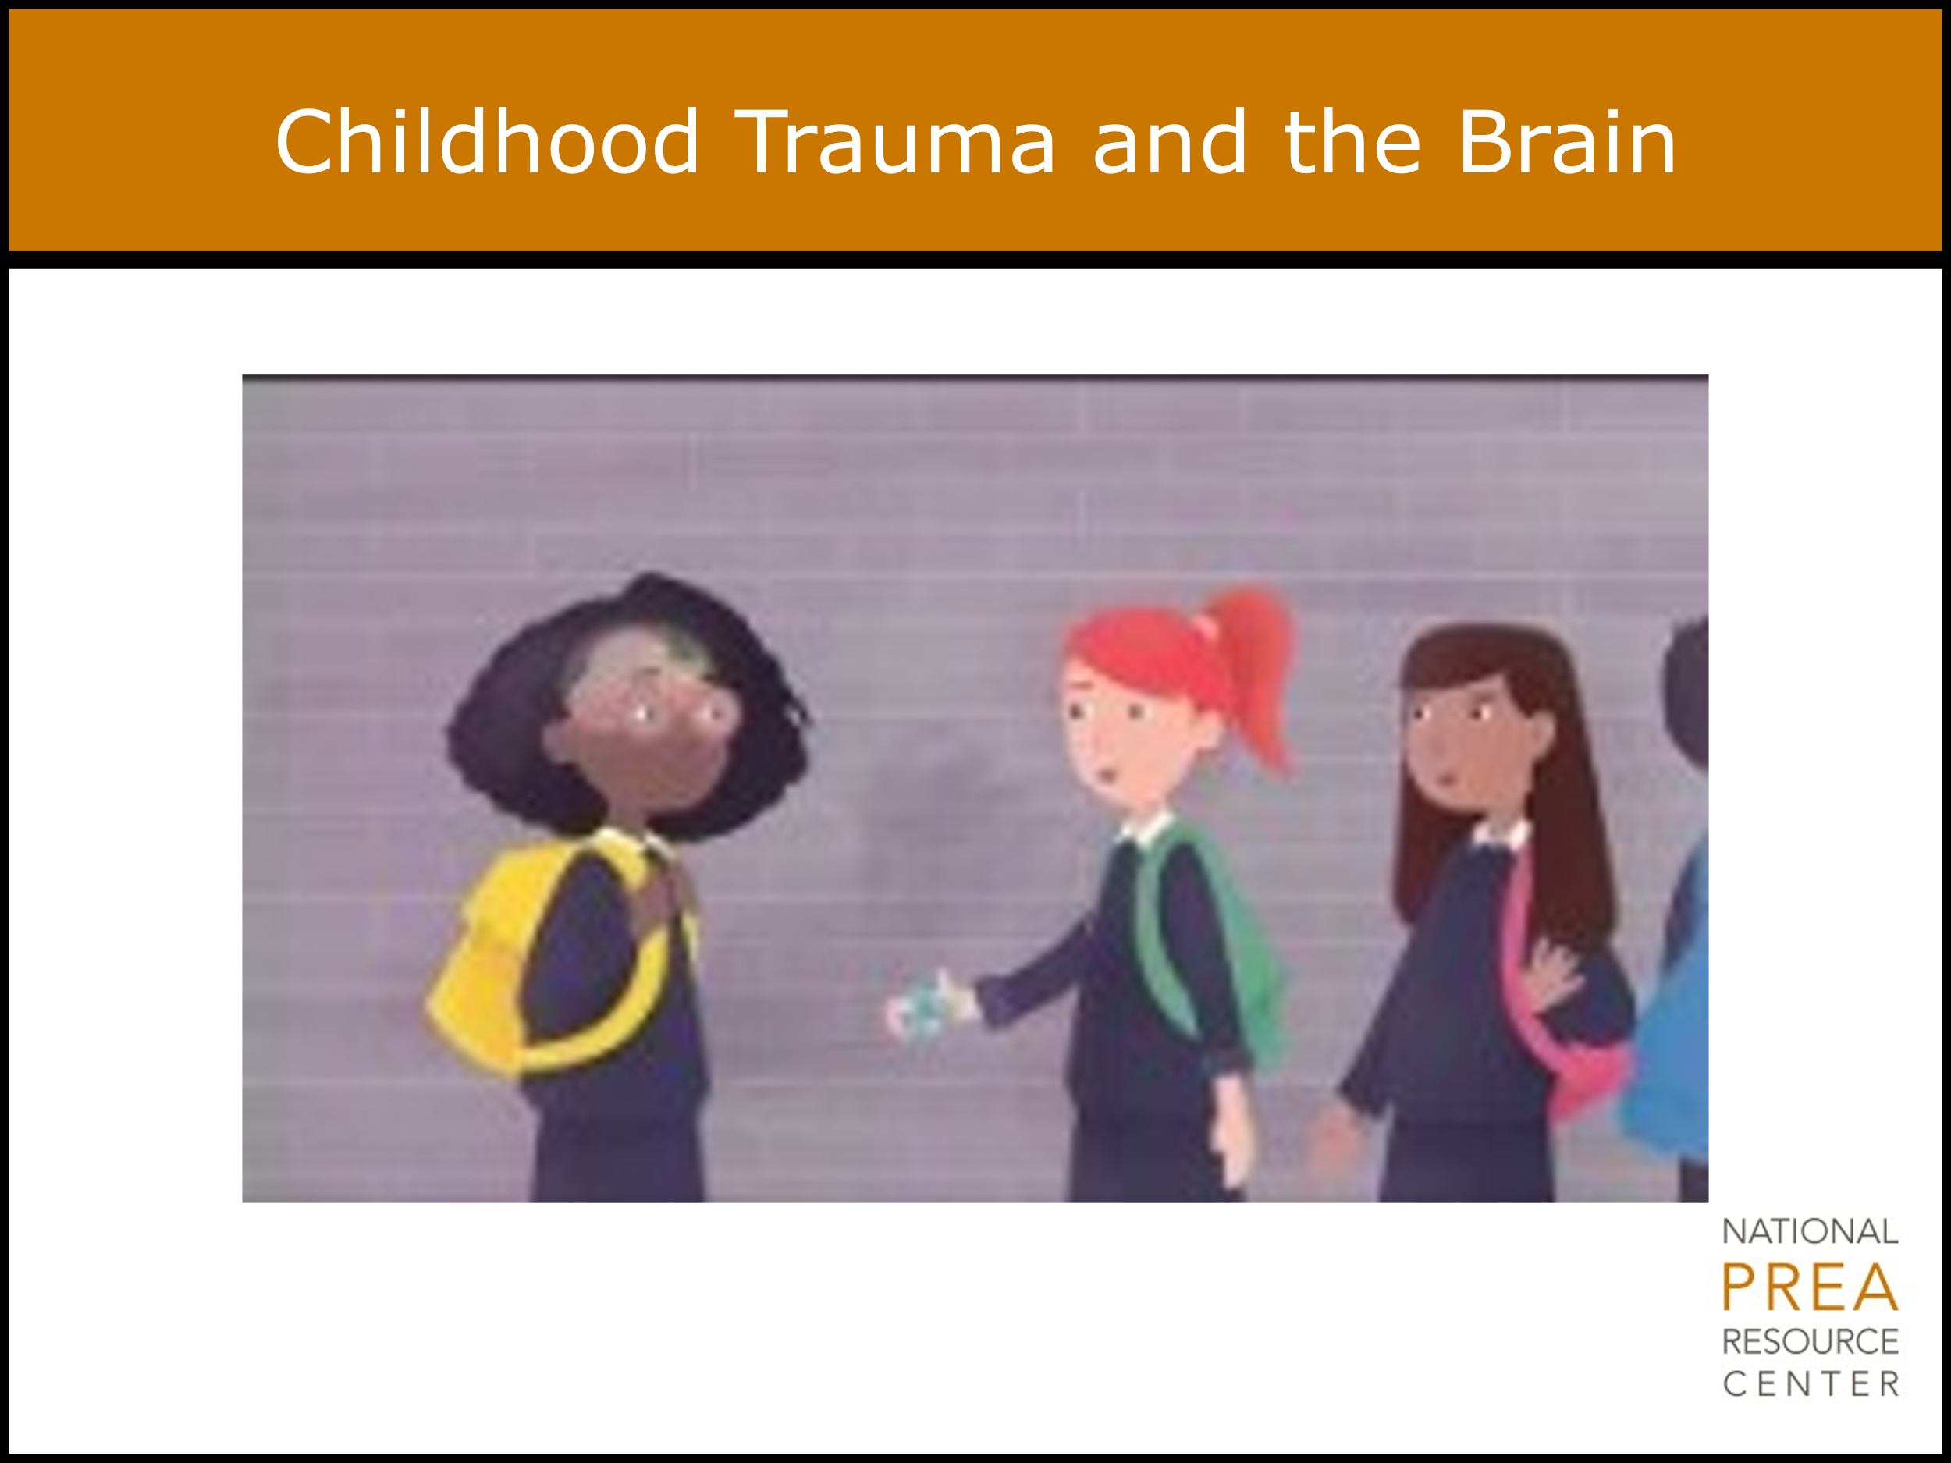 | Childhood Trauma and the Brain    Video link: https://www.youtube.com/watch?v=xYBUY1kZpf8  This video provides insight into how childhood trauma affects the brain. Many inmates will have experienced childhood trauma (noted in slide 13), so this video helps give additional clarity to how that impacts later in life.
1 min | Percentage of Inmates Reporting Childhood Physical Abuse  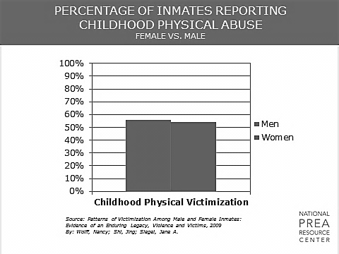  As you can see on the slide, many of the inmates/residents with whom you work have experienced traumatic events in their lives, regardless of whether they have reported an incident of sexual abuse during their incarceration.  You may witness these trauma symptoms in other types of investigations you conduct. You may be able to use skills from this training in work that is not directly related to sexual abuse. Additionally, remember that abuse histories are not unique to offenders; staff being interviewed may have similar histories and may demonstrate similar symptoms of trauma or PTSD. | This is an excellent opportunity to use agency-specific data, which will likely be more meaningful for agency staff.  The data that is provided is the most recently available national-level data.
1 min | Percentages of Inmates Reporting Childhood Sexual Abuse  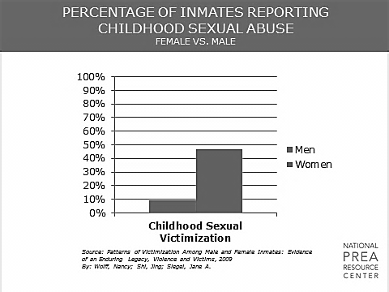  Women and girls in the criminal justice system have particularly significant trauma histories, as many of them have experienced sexual abuse prior to incarceration. | This is an excellent opportunity to use agency-specific data, which will likely be more meaningful for agency staff.  The data that is provided is the most recently available national-level data.
2 min | Impact of Sexual Abuse  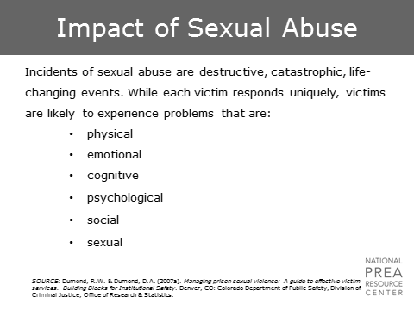  Sexual abuse is catastrophic. It is life changing.  - It can impact the victim’s physical, emotional, cognitive, psychological, social and sexual health.  - In the aftermath of sexual abuse, a victim may experience physical trauma directly related to the victimization experience; medical issues including HIV/AIDS, sexually transmitted infections, and other communicable diseases; pregnancy (for women); and psychological trauma including anxiety, depression, PTSD or rape trauma syndrome, dissociative disorders, and exacerbation of pre-existing psychiatric problems.  The physical trauma, medical issues, and possibility of pregnancy will be addressed by the medical personnel and Sexual Assault Nurse Examiners (SANE) at your facilities or in your community. The victim will also have access to mental health practitioners.  However, it is extremely important for the investigator of a sexual abuse case to be aware of the psychological ramifications of trauma. Knowing these ramifications can assist an investigator in  - Interacting with the victim in a way that will enhance their willingness and ability to fully participate in the investigation and  - Interacting with the victim in a way that facilitates the healing process or, at the very least, does not cause further harm. | SOURCE: Dumond, R.W. & Dumond, D.A. (2007a). Managing prison sexual violence: A guide to effective victim services. Building Blocks for Institutional Safety. Denver, CO: Colorado Department of Public Safety, Division of Criminal Justice, Office of Research & Statistics.  SOURCE: A Guide to An Effective Medical Response to Prisoner Sexual Violence  (Monograph for Colorado Department of Public Safety – Dumond & Dumond, 2007)
3 min | Impact of Sexual Abuse  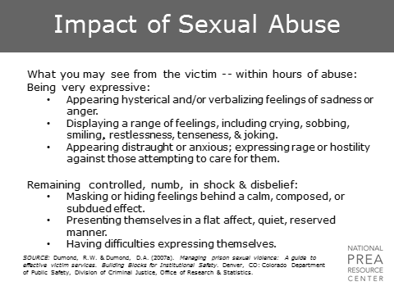  During an incident of sexual abuse, a victim experiences a total lack of control. They experience pain and feel that their lives are being threatened. Following an incident, victims are often in a state of shock, disbelief, or panic.  In the short- and long-term following an incident, victims may become  - Depressed,  - Anxious, and,  - If symptoms do not fade with time, may be diagnosed with Post Traumatic Stress Disorder (PTSD).  Victims of sexual abuse are significantly more likely to attempt suicide.  - They are four times more likely than non-crime victims to have contemplated suicide.  - They are fourteen times more likely than victims of other types of crimes to have actually attempted suicide.  If you interact with a victim immediately after an incident of sexual abuse, victims may demonstrate a range of reactions. Some will be extremely emotional. These emotions may range from  - Hysteria, sadness, anger, and hostility to  - Restlessness, tenseness, and even joking.  Other victims may demonstrate no emotion at all.  - They may be numb, in shock, or have difficult expressing themselves.  - Others may not be comfortable expressing emotion and therefore may appear totally calm, composed and quiet.  All of these reactions are perfectly normal. Do not expect a sexual abuse victim to act in any particular way. Also, do not make snap judgments concerning the validity of a report/account based on the mannerisms of the person talking about it. | Dumond, R.W. & Dumond, D.A. (2007a). Managing prison sexual violence: A guide to effective victim services. Building Blocks for Institutional Safety. Denver, CO: Colorado Department of Public Safety, Division of Criminal Justice, Office of Research & Statistics.  Allison, J.A. & Wrightsman, L.S. (1993). Rape: The misunderstood crime. Newbury Park, CA: Sage Publications and Dumond,  Robert W. & Dumond, Doris A. (2002). The treatment of sexual assault victims. In C. Hensley (Ed.), Prison sex: Practice and policy. Boulder, CO: Lynne Rienner Publishers, Chapter 5, pp. 67-88
2 min | Impact of Sexual Abuse  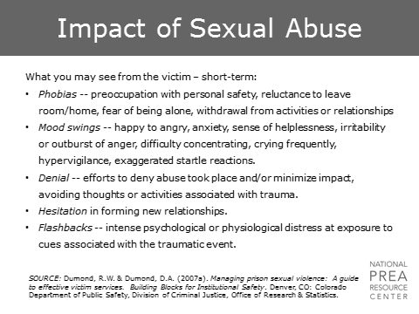  Victims of sexual abuse will experience a range of emotions in the weeks following the incident. They may experience  - Re-traumatization due to “triggers” in their environment.  - Shock, denial, humiliation, self-doubt, guilt, shame, self-blame, depression, and self-hatred.  - Anger, a desire for revenge, or suicidal thoughts.  Remember that victims have experienced a significant feeling of powerlessness and may feel anxious and fearful. Finding ways to allow the victim to feel in control will contribute to the victim’s comfort and will increase the likelihood of an effective investigation.  Following the first few weeks, victims may develop  - Fear of being alone or being around others.  - Significant changes in behavior.  - Disinterest in activities they previously enjoyed.  - Mood swings.  - Difficulty concentrating.  Victims may also become hyper-vigilant or be easily startled.  Many victims also go through periods of denial, which may influence their reporting of the incident.  They may be hesitant to form new relationships and may not trust new people they meet, including you, the investigator.  Finally, they may experience flashbacks that cause intense distress and are triggered by reminders of the trauma. | SOURCE: Dumond, R.W. & Dumond, D.A. (2007a). Managing prison sexual violence: A guide to effective victim services. Building Blocks for Institutional Safety. Denver, CO: Colorado Department of Public Safety, Division of Criminal Justice, Office of Research & Statistics.
2 min | Impact of Sexual Abuse  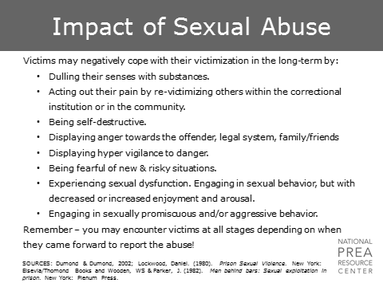  In the long-term, if a victim is unable to cope with the symptoms in the aftermath of a trauma, she or he may  - Turn to alcohol or drug use.  - Act out and become aggressors themselves.  - Become self-destructive.  - Develop post-traumatic stress disorder.  For those victims who experienced abuse within the correctional system, they may  - Display strong feelings of anger towards the system as a whole, or towards people who are trying to help them.  - Continue to be hyper-vigilant to danger and feel anxious and fearful about new situations.  - Change their view of sexual activity, impacting their ability to enjoy it or resulting in promiscuous or aggressive sexual behavior.  Victims of sexual abuse may report at any point after the incident – hours later or years later - though many never report at all. In your interactions with inmates/residents, be aware of how trauma may impact their behavior and the way your interaction with a victim may impact their desire or ability to cooperate with an investigation.  Similarly, be aware of the impact of trauma more generally. Do not just apply your knowledge of trauma to cases involving sexual abuse. Use this knowledge in other cases that may involve elements of sexual abuse that you are not aware of, or when interacting with inmates/residents who may have suffered from sexual abuse at some point in lives previous to incarceration. | SOURCES: Dumond & Dumond, 2002; Lockwood, Daniel. (1980). Prison Sexual Violence. New York: Elsevia/Thomond Books and Wooden, WS & Parker, J. (1982). Men behind bars: Sexual exploitation in prison. New York: Plenum Press.
1 min | Impact of Sexual Abuse: Corrections  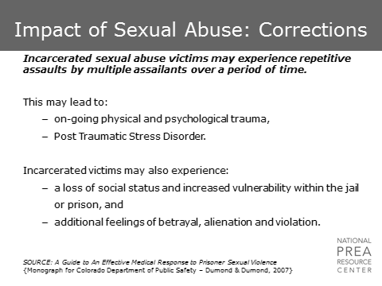  Sexual abuse in corrections is unique due to the setting in which it takes place. Victims of sexual abuse in corrections  - May experience repetitive assaults by multiple assailants over a period of time.  - Are confined to the location of the sexual abuse and cannot escape the environment of people that caused them harm.  This level of trauma is debilitating and can lead to severe and chronic Post-Traumatic Stress Disorder. Sexual abuse in corrections can impact the victim’s social status and safety within the facility and may impact the victim’s trust in the system as a whole.  Sexual harassment can also be as traumatizing as sexual abuse in incarcerated settings. It may be repetitive, graphic, demoralizing, and vulgar. Sexual harassment can be even more difficult to prove than sexual abuse. | SOURCE: A Guide to An Effective Medical Response to Prisoner Sexual Violence  {Monograph for Colorado Department of Public Safety – Dumond & Dumond, 2007}
1 min | Impact of Sexual Abuse: Men  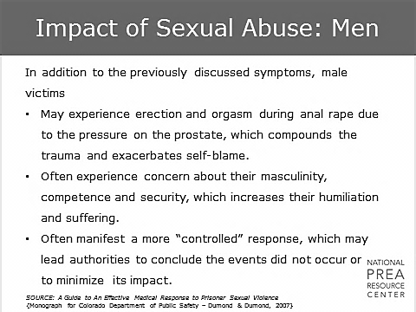  - Men and boys in particular may experience heightened levels of shame, humiliation, and self-blame due to their perceptions of a loss of masculinity.  - This is particularly true in cases of anal rape in which the victim experiences an erection.  - Males may present a more controlled response when reporting as well, which can cause authorities to take the reports less seriously or not believe the report at all. | SOURCE: A Guide to An Effective Medical Response to Prisoner Sexual Violence  {Monograph for Colorado Department of Public Safety – Dumond & Dumond, 2007}
1 min | Impact of Sexual Abuse: Women  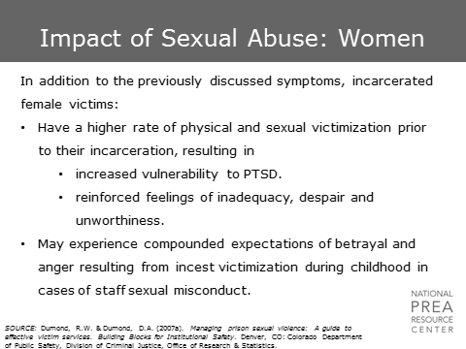  The women and girls with whom you will work in corrections have extremely high rates of physical and sexual victimization in their pasts. These histories  - May increase feelings of despair and inadequacy, and  - May inhibit their ability to identify sexual abuse in their relationships.  In cases of staff sexual misconduct, women may suffer from particularly strong feelings of betrayal if they experienced incest victimization in childhood. | SOURCE: Dumond, R.W. & Dumond, D.A. (2007a). Managing prison sexual violence: A guide to effective victim services. Building Blocks for Institutional Safety. Denver, CO: Colorado Department of Public Safety, Division of Criminal Justice, Office of Research & Statistics.
1 min | Implications  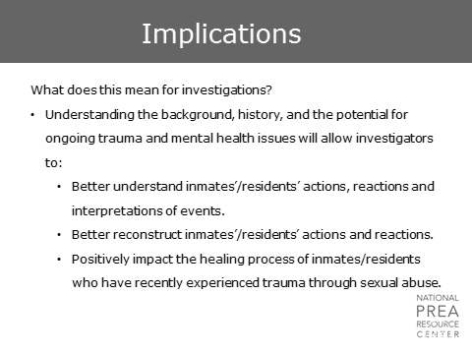\  What does this mean for investigations? Be aware  - Of the histories of the inmates/residents with whom you are working and how that may impact their perception of events within the facility.  - Behaviors that may seem bizarre or inexplicable to you may be coping mechanisms for trauma.  To fully understand an allegation and determine the validity of it, an investigator needs to attempt to understand the mindset of the inmates/residents with whom they work.
10 min | Implications: How to be Trauma Informed  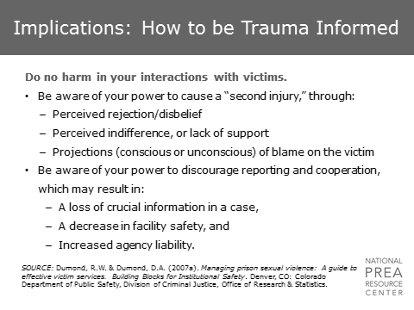  Understand that you can do harm to the victims with whom you work. You can avoid doing harm by  - Acting professional with all inmates/residents, regardless of their behavior or allegations, and  - Avoiding any displays of skepticism when working with an alleged victim.  If you do not consider trauma in your work, you can cause what is known as a “second injury” to the victim if  - They perceive you as having rejected their report or having not believed them.  - You seem indifferent, or seem to be blaming the victim in any way, which may add to the victim’s trauma.  You can also unintentionally discourage reporting throughout the facility.  - Inmates/residents talk, and your treatment of an alleged victim during an interview will become common knowledge throughout the facility.  - Expressions of disbelief or indifference in one case – even if the case is determined to be unfounded – may impact the reporting of others in the facility who may actually need your help.  Activity | SOURCE: Dumond, R.W. & Dumond, D.A. (2007a). Managing prison sexual violence: A guide to effective victim services. Building Blocks for Institutional Safety. Denver, CO: Colorado Department of Public Safety, Division of Criminal Justice, Office of Research & Statistics.  Conduct a small group activity. Divide the class into small groups with easel pads and provide the scenario handout.  Refer to “Module 4 Handout 1” attachment.  Have each group draw a line down the middle of their pad and, based on the scenario provided, list questions to ask in a victim interview on the left and how to reword that question to be “trauma-informed” in the right column.
2 min | Implications: How to be Trauma Informed  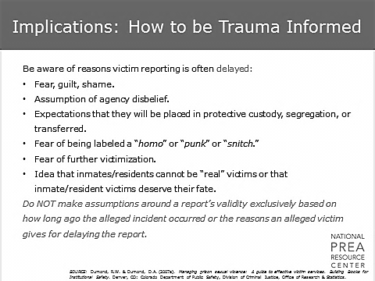  There are many reasons victims delay reporting. Many victims experience fear, guilt, and shame. In the community, cases of sexual abuse are often not reported for those reasons as well.  In corrections, there are even more barriers to reporting, including  - Fear that they will be disbelieved due to their status as inmates/residents.  - Fear that they will be put in segregated housing.  - Fear that their reputation among other inmates/residents may be damaged in a way that may actually impact their safety. Predators in facilities will often view admissions of victimization as signs of weakness, so reporting may put victims at further risk.  - Cultural barriers among staff who believe that all sex going on is consensual or that sexual abuse is part of the punishment if you break the law and get put in custody.  Consider these issues when investigating reports of sexual abuse that you receive after-the-fact. A delay in reporting should not, by itself, influence an investigator’s perception of the validity of an allegation. | SOURCE: Dumond, R.W. & Dumond, D.A. (2007a). Managing prison sexual violence: A guide to effective victim services. Building Blocks for Institutional Safety. Denver, CO: Colorado Department of Public Safety, Division of Criminal Justice, Office of Research & Statistics.
1 min | Implications: How to be Trauma Informed  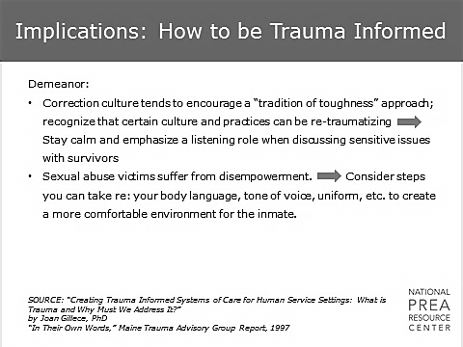  So, what can you do to avoid causing a “second injury?” Be aware of your demeanor.  - The “tough guy” approach is not the best way to get a victim of sexual abuse to cooperate with an interview.  - Because an incident of sexual abuse is extremely disempowering, consider steps you can take to minimize the inmate/resident’s feelings of disempowerment during the interview.  - Emphasize collaboration rather than compliance.  Pay attention to your body language. You can physically trigger flashbacks in someone who has experienced trauma by standing over him or her, standing too close to him or her, brushing up against him or her, staring or speaking too close to his or her face, or touching him or her. | SOURCE: “Creating Trauma Informed Systems of Care for Human Service Settings: What is Trauma and Why Must We Address It?”  by Joan Gillece, PhD  “In Their Own Words,” Maine Trauma Advisory Group Report, 1997  SOURCE: Trauma Addictions Mental Health and Recovery (TAMAR) Treatment Manual and Modules
1 min | Implications: How to be Trauma Informed  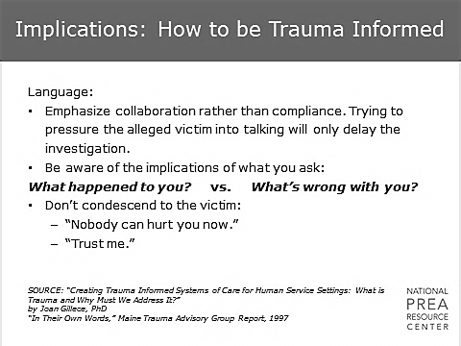  Be aware of your language choices.  - Emphasize collaboration rather than compliance.  - Do not try to pressure the victim into talking; this will only delay the investigation.  - When you ask questions, be aware of the implications. For example, when you ask, “Why is this upsetting? Have you had sex before?” this implies that the sexual abuse was in some way the victim’s fault. Try to avoid any questions or statements that will increase the victim’s self-blame, guilt, or shame.  - Avoid being condescending or making promises you cannot keep.  Many of the victims will be unlikely to trust you. This may be because  - You are a new person to them  - You are part of the correctional agency  - You are part of a law enforcement agency that was not able to assist them during earlier victimizations  - You are part of a law enforcement agency that played a role in their incarceration  Be honest and straight-forward with the victim. The faster you can gain their trust, the faster you will get the full story. | SOURCE: “Creating Trauma Informed Systems of Care for Human Service Settings: What is Trauma and Why Must We Address It?” by Joan Gillece, PhD  “In Their Own Words,” Maine Trauma Advisory Group Report, 1997
1 min | Implications: How to be Trauma Informed  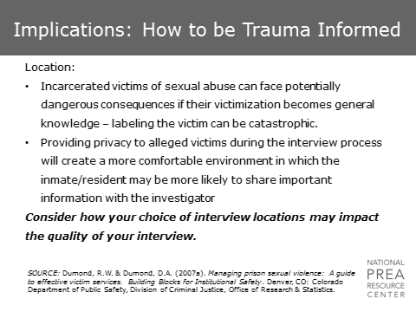  Consider how your choice of interview locations may impact the quality of your interview.  Interview the victim  - In a private location  - Away from their housing unit  - If the allegation is of staff sexual misconduct, during a shift when the suspected staff member is not working  If you are not arranging the location of the interview, be sure to ask that the location be as neutral as possible. Do not, for example, interview the inmate/resident in the location of the alleged incident or in the presence of other staff or inmates/residents.  Keep the purpose of the interview confidential to provide maximum confidentiality to the victim. | SOURCE: Dumond, R.W. & Dumond, D.A. (2007a). Managing prison sexual violence: A guide to effective victim services. Building Blocks for Institutional Safety. Denver, CO: Colorado Department of Public Safety, Division of Criminal Justice, Office of Research & Statistics.
1 min | Implications: How to be Trauma Informed  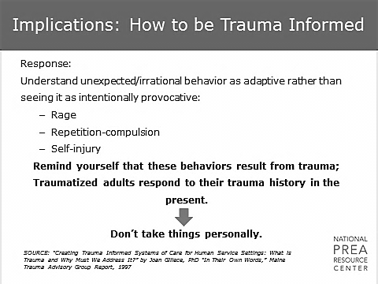  If an inmate/resident is hostile or uncooperative during an interview, do not take it personally. Remember  - Survivors are living out their trauma in the present.  - Getting frustrated or angry will only exacerbate the situation.  - To seek help from a mental health practitioner or victim advocate if you need advice. | SOURCE: “Creating Trauma Informed Systems of Care for Human Service Settings: What is Trauma and Why Must We Address It?” by Joan Gillece, PhD “In Their Own Words,” Maine Trauma Advisory Group Report, 1997
1 min | Implications: How to be Trauma Informed  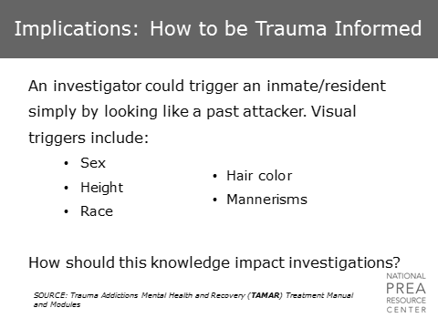  Finally, your sex, height, race, hair, or mannerisms could trigger an inmate/resident.  - If you can adjust something to make the victim feel more comfortable, do so.  - If you can’t, consider asking someone else to conduct the interview. | SOURCE: Trauma Addictions Mental Health and Recovery (TAMAR) Treatment Manual and Modules
1 min | Implications: How to be Trauma Informed  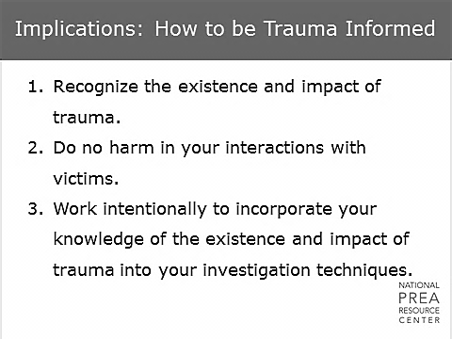  To summarize, trauma-informed practices require the investigator to recognize that trauma exists and can have a significant impact on the victim. In order to do no harm and to increase the likelihood of a successful investigation, investigators need to work intentionally to incorporate their knowledge around trauma into their investigation techniques. | Additional information on taking a trauma-informed approach to working with victims can be found on Handout 2.  Refer to “Module 4 Handout 2” attachment.
1 min | Questions?

