Module 1: PREA Update and Investigative Standards Overview Guidance for the Field

Time: 9:00 a.m. – 10:15 a.m. (1 hour and 15 min)

Training Objectives:
- Understand a timeline of Public Law 108-79, The Prison Rape Elimination Act
- Describe the PREA standards relevant to investigations

Materials Needed:
- Easel pad and markers
- PowerPoint® player/machine (laptop computer and LCD projector)
- Screen or monitor
- Handout: United States Department of Justice National Standards to Prevent, Detect, and Respond to Prison Rape (2012). Note that both the Prison and Jails Standards and the Juvenile Standards are provided as handouts. Select the set of standards appropriate to the population of your agency.
- Handout: Your Words, My Words (optional)

Training Tips:
- The purpose of this module is to ensure participants have a good understanding of the PREA standards relevant to investigations. To do this, a trainer needs to engage the audience. Simply lecturing on these slides will not hold your participants’ interest; invite participants to ask questions and encourage discussion on the standards. Engaging participants in discussion will increase retention and ensure a higher interest level.
- This module was designed to address the standards with specific relevance to investigations. As a result, additional PREA standards are not included in this module. The flash drive of resources provided to instructors with this curriculum includes PowerPoint® presentations containing every standard. This may be helpful if you wish to cover additional standards in this module.
- Be advised that this module may contain material that utilizes concepts and language that may be upsetting or difficult for some participants. This may include statements referring to genitalia, sexual harassment, sexual abuse, trauma and suicide. Videos used may also contain profanity and graphic language, including references to sexual abuse and trauma. Please review all materials prior to using to ensure they are appropriate for use in your agency and make substitutions where needed. You should also consider providing a general notice to participants at the beginning of each training session.

- Please note that this module was developed specifically for facilities that use the Adult Prisons and Jail or Juvenile PREA Standards. Facilities using the Community Confinement or Lockup standards should review all standard references to ensure that the content and language is appropriate for their facility type and inmate/resident population and adjust the material as needed to their specific circumstance.

Time | Lecture Notes | Teaching Tips
1 min | Overview of the Prison Rape Elimination Act (PREA) | 
 | Objectives  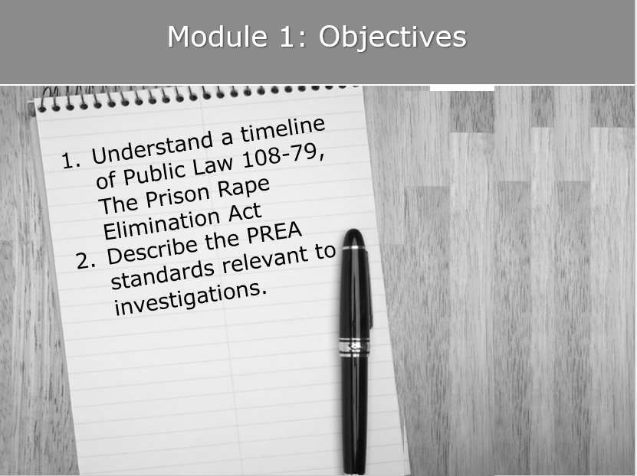  In this module, we are going to give you an overview of the PREA standards that impact your agency. The learning objectives are to provide you with an update on PREA and compliance, as well as provide an in-depth review of the PREA standards that relate to investigations. |   Objectives    Provide participants with a full copy of the PREA standards appropriate to the population of their agency. State that you will only be going over select standards, but you encourage them to review the full set of standards.
1 min | PREA Release 2012  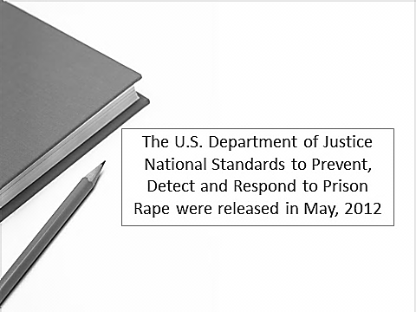  The United States Department of Justice National Standards to Prevent, Detect, and Respond to Prison Rape were released in May, 2012. They were published in the Federal Registrar in June, 2012, and they officially became effective in August, 2012. | PREA Release 2012
3 min | PREA Standards Timeline  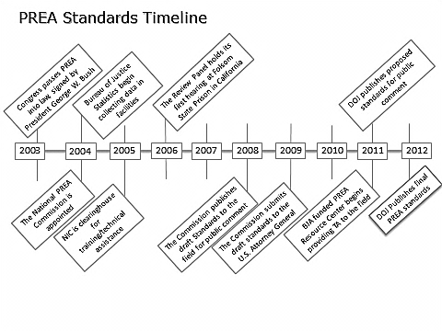  This timeline provides a broad idea of the process through which the standards were developed. There were a number of draft versions of the standards.  The PREA law was passed in 2003. Between 2003 and 2008, the first version of the draft standards were developed by the National Prison Rape Elimination Commission. Simultaneous to that development, the Bureau of Justice Statistics was collecting data on the actual incidence of sexual abuse in correctional settings in the United States, since there was no national data in existence. The National Institute of Corrections also began providing technical assistance during that time, and the PREA Review Panel began holding hearings based on the data collected by the Bureau of Justice Statistics.  After field review, the National Prison Rape Elimination Commission submitted their recommended standards to the U.S. Attorney General’s Office in 2009, and the Department of Justice (DOJ) PREA Working Group published a second version of the standards in 2011. Those Standards were revised and finalized in 2012. | PREA Standards Timeline
2 min | PREA Standards  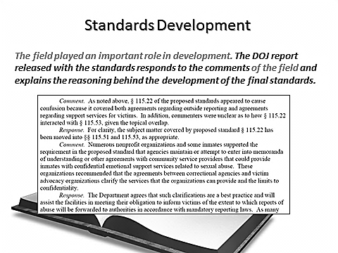  After each draft of the standards was released, the field was invited to submit comments on the standards in which they could state their support or request revisions. The final report released with the PREA Standards contains extensive discussion of the comments received from the field, and how they influenced the development of the final standards. | PREA Standards  Use this slide to emphasize the role played by the field in the development of the standards. The report released by the DOJ in conjunction with the standards responds to the comments from the field, and explains why the PREA Working Group made the decisions they did.
3 min | PREA Audit Timeline  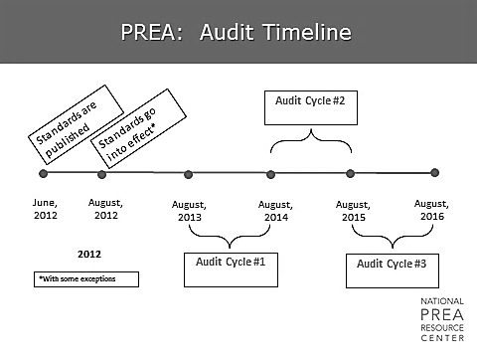  The final rule was  - published on June 20, 2012, and  - became effective on August 20, 2012.  - Note the asterisk. Certain standards do not go into effect until a later date (e.g., prohibition on cross-gender pat searches of women offenders which becomes effective in 2015 or 2017 depending on facility size, and juvenile staffing ratios which go into effect in 2017).  The first audit cycle begins on Aug. 20, 2013, and, to be in compliance, jurisdictions are required to audit:  - at least one third of their facilities within the subsequent 12-month period ending August 20, 2014.  - another one third of their facilities between August, 2014, and August, 2015,  - the final third of their facilities between August, 2015, and August, 2016. | PREA Audit Timeline
2 min | How is compliance determined?  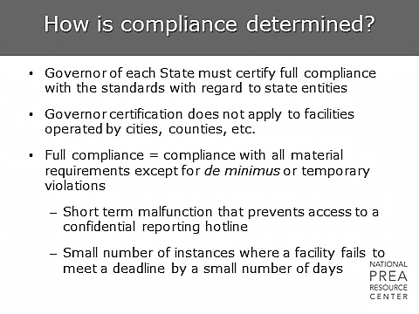  What does “compliance mean?”  Governors of each state will certify compliance for all state-level agencies. Full compliance entails meeting all material requirements, which will be identified by the audit instrument. If a facility is temporarily not meeting the requirements, or has minor issues of non-compliance, these facilities can still be considered to be in full compliance. An example of a minor issue of non-compliance would be if a hotline is temporarily malfunctioning or a facility missed a deadline by a small number of days. | How is Compliance Determined?
2 min | How is compliance determined?  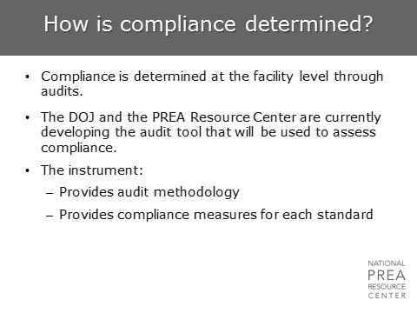  The adult prison/jail instrument was pilot tested in two BOP prisons, and released to the general public in May, 2013. The other three tools (juveniles, community residential facilities, lock-ups) will follow. Exact timeline is still to be determined. | How is Compliance Determined?
2 min | How is Compliance determined?  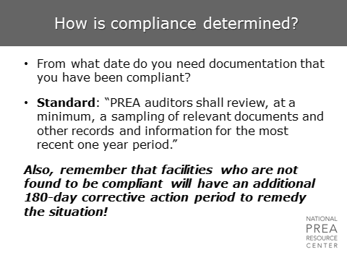  The first few years of auditing will be unique as the field comes into compliance. Moving forward, audits will look at the one-year period preceding the audit to determine compliance. | How is Compliance Determined?
2 min | Sexual Abuse – Statistics  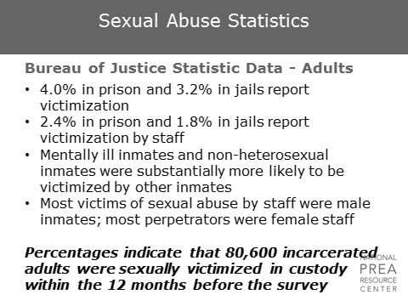  This was the data collected in the 2011-2012 National Inmate Survey conducted by the Bureau of Justice Statistics.  Note that 6.3% of inmates in prisons with serious psychological distress reported sexual victimization by another inmate, and 3.6% reported in jails.  Among non-heterosexual inmates, 12.2% of prisoners and 8.5% of jail inmates reported being sexually victimized by another inmate; 5.4% of prisoners and 4.3% of jail inmates reported victimization by staff. | Sexual Abuse Statistics  Only use this slide if your agency has an adult population.  This is an excellent opportunity to use agency-specific data, which will likely be more meaningful for agency staff.  The data that is provided is the most recently available national-level data.  Beck, Allen Ph.D. et al. Sexual Victimization in Prisons and Jails Reported by Inmates, 2011-12. Washington, DC: U.S. Department of Justice, Bureau of Justice Statistics.  Refer to the “Sexual Victimization in Prisons and Jails Reported by Inmates, 2011-12” attachment.  Put your participants into teams of two and have them discuss: What does this data mean? Is it consistent with my own experience? Does anything surprise me/ How can I learn from the data?
2 min | Sexual Abuse – Statistics  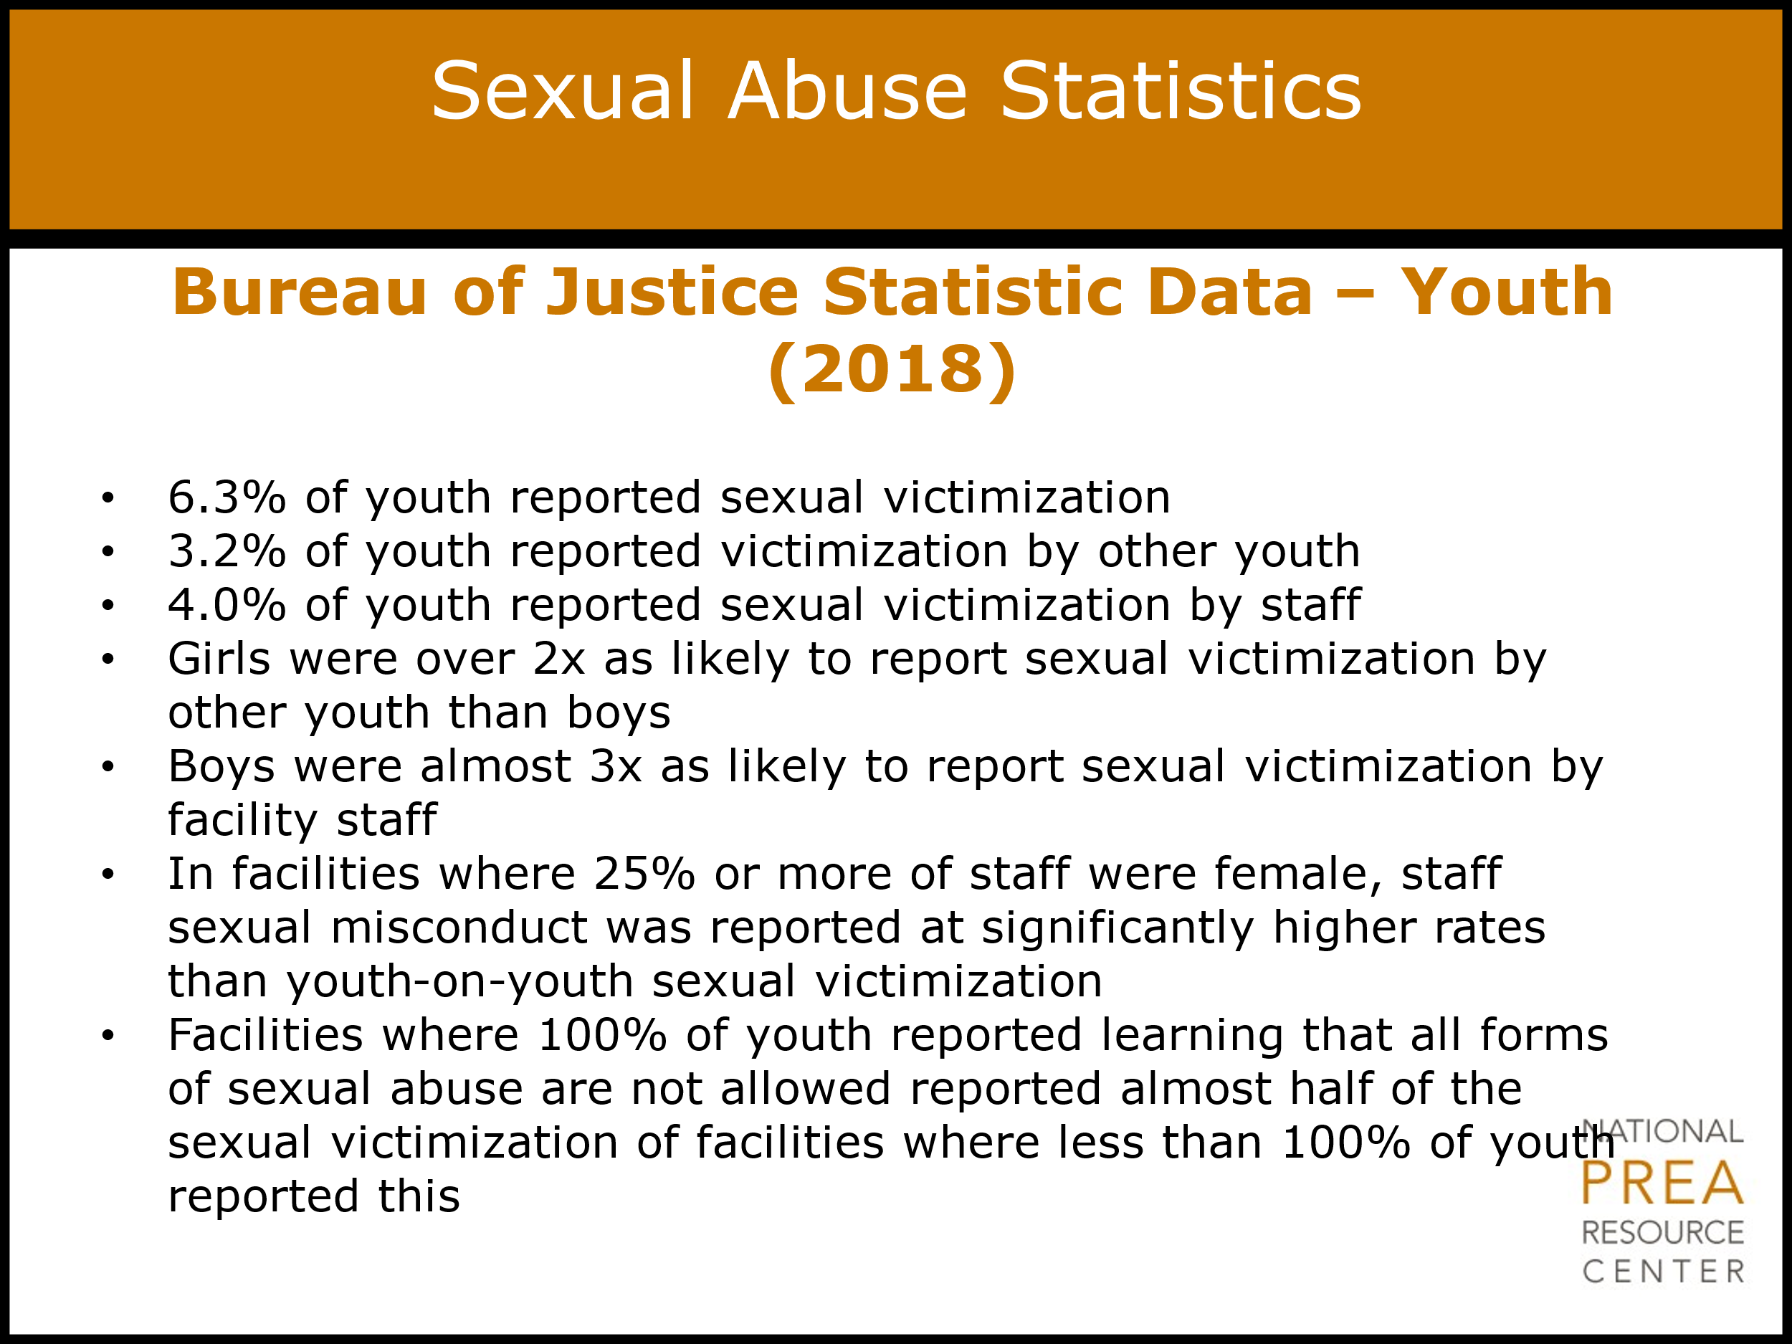  This was the data collected in the 2018 National Survey of Youth conducted by the Bureau of Justice Statistics. | Sexual Abuse Statistics  Only use this slide if your agency has a juvenile population.  This is an excellent opportunity to use agency-specific data, which will likely be more meaningful for agency staff.  The data that is provided is the most recently available national-level data.  Lauger, Amy D.; Field, Michael B. Facility Characteristics of Sexual Victimization of Youth in Juvenile Facilities, 2018. Washington, D.C., 2018. U.S. Department of Justice, Bureau of Justice Statistics.  Refer to the “Facility Characteristics of Sexual Victimization of Youth in Juvenile Facilities, 2018” attachment.  Put your participants into teams of two and have them discuss: What does this data mean? Is it consistent with my own experience? Does anything surprise me/ How can I learn from the data?  Note that this exercise is repeated twice. If your agency has both juvenile and adult populations, do not repeat this exercise.  It is not unusual for participants to challenge the data. This federal initiative has brought together some of the best thinkers in data collection. However, this is a difficult area in which to collect data and we continue to learn as we move forward.  Refer to the “PREA Final Rule” attachment.
2 min | Sexual Abuse – Statistics  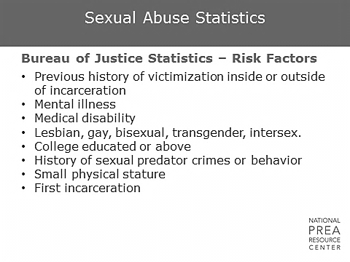  After years of collecting research on sexual abuse in confinement settings, the Bureau of Justice Statistics has identified these most significant risk factors. As investigators, it is both critical to be educated, and critical not to make assumptions because an inmate/resident exhibits any of these characteristics. These factors increase the likelihood of abuse but are not indicators of abuse. | Sexual Abuse Statistics  Continue with the participants in teams of two and have them discuss: Why would these characteristics create greater vulnerability?
3 min | PREA Investigative Standards  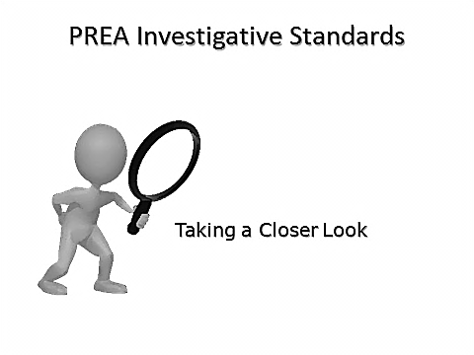  The following slides contain summaries of some of the key standards related to investigations. Staff may benefit from reading the full standards; the standards discussed below are focused on the standards relevant to the investigative standards.  There are four separate sets of PREA standards:  - Adult Prisons and Jails  - Juvenile Facilities  - Community Confinement Facilities  - Police Lockups  During this module, we will only be reviewing some of the key standards from the Adult Prisons and Jails and Juvenile Facilities standards.  However, it is important that you have read all of the standards applicable to your agency, as well as the Executive Summary that precedes the standards in the Department of Justice final rule and explains the considerations of the PREA Working Group during development of each standard. The Executive Summary is available online at the PREA Resource Center website at www.prearesourcecenter.org. | PREA Investigative Standards  Trainers will benefit from reading the full standards and familiarizing themselves with agency PREA and investigations policies to ensure all key areas relating to their agency’s investigation of sexual abuse and sexual harassment processes are addressed.  Be sure your module uses the standards that are applicable to your training participants.  Refer to the “PREA Final Rule” attachment.
3 min | Section 115.5: DEFINITIONS  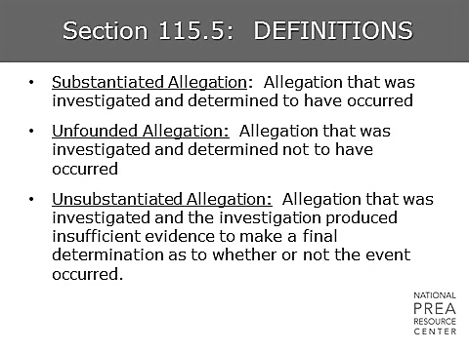  There are 46 standards, two of which are definitions. It is critical to know the definitions used in the PREA standards. Why?  When PREA was first enacted and the Bureau of Justice Statistics began their work, there were no nationally accepted definitions. This was particularly true in the documentation of investigations. The effort to collect data from the field consistently may be one of the most important contributions to understanding sexual abuse in corrections.  Consistent definitions allow for…  - Clarity of prohibited behaviors. One person’s definition of sexual abuse will rarely be exactly the same as another’s. Stating the agency has a zero-tolerance policy concerning sexual abuse of inmates/residents does not define what is meant by sexual abuse. It is critical that definitions are included in policy so that staff and others are perfectly clear about what specific behavior is prohibited.  - Data reporting. While no agency is required to use the PREA definitions of sexual abuse in their policy, agencies must use those definitions when submitting the annual data reporting on all allegations of sexual abuse and sexual harassment.  - Consistency. Definitions of prohibited behaviors should be consistent throughout policy, align with state laws, and align with definitions in PREA standards.  The definitions of sexual abuse and sexual harassment will be discussed in greater detail later in the training. | Definitions  You may wish to insert definitions used by your agency here.  Optional Class Exercise: Your Words, My Words.  Refer to the “Your Words, My Words” attachment.  OR  Have a brief discussion with participants around why definitions are important, both to investigators and to line staff.
2 min | Section 115.(3)21: Evidence Protocol and Forensic Medical Exams  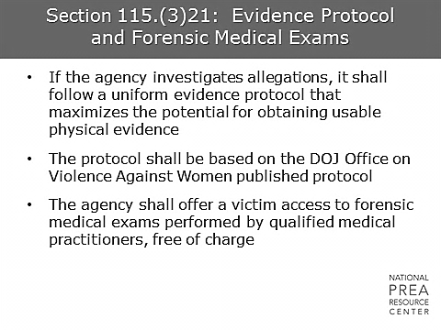  The agency conducting investigations is required to use a uniform evidence collection protocol to ensure all investigations and the procedures followed therein are standardized to maximize the success of potential prosecutions.  The agency is also required to offer victims free access to forensic medical exams performed by qualified medical practitioners, ideally Sexual Assault Nurse Examiners (SANE) or Sexual Assault Forensic Examiners (SAFE).  The protocol mentioned in the standard was developed for the community by the Office on Violence Against Women (OVW). The Vera Institute of Justice has worked with OVW to develop a similar protocol that is specific to the corrections environment and is currently pending publication. | Evidence Protocol and Forensic Medical Exams  If you are training Module 5, reference that module here. If you are not including it, mention that the forensic medical exam process is extremely thorough and can be re-traumatizing for the victim. The exam can be used to collect valuable evidence, but an inconclusive exam is not evidence that sexual abuse did not occur. For investigators unfamiliar with the process, recommend that they review the most recent addition of the U.S. DOJ’s Office on Violence Against Women publication, A National Protocol for Sexual Assault Medical Forensic Examinations, Adults/ Adolescents.  Refer to “National Protocol for Sexual Assault Medical Forensic Examinations Adults Adolescents” attachment.  Insert relevant agency policies here.
2 min | Section 115.(3)21: Evidence Protocol and Forensic Medical Exams  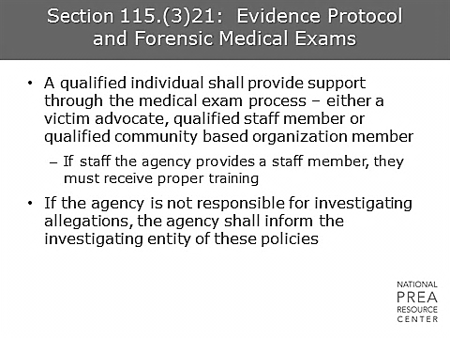  This standard requires the presence of a victim advocate or, if a victim advocate is unavailable, a qualified staff member. | Evidence Protocol and Forensic Medical Exams  Insert agency policy regarding victim advocates and current agency agreements with victim advocacy providers.
2 min | Section 115.(3)22: Policies to ensure referrals of allegations for investigations  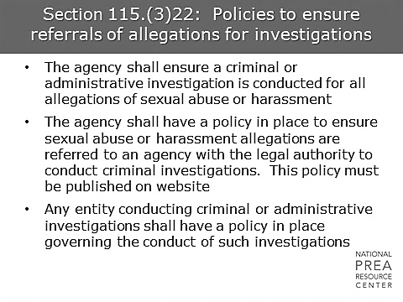  This is one of the few standards that requires policy. Our policy states… | Policies to ensure referrals of allegations for investigations  Ensure participants understand that this standard requires that there is no screening instrument for allegations; all allegations are referred for investigation. This means no dismissal by the warden, and no judgments based on past allegations.  It is also important to note that criminal and administrative investigations focus on different aspects of alleged sexual abuse and harassment, therefore the agency must review the facts and determine separately whether to refer an allegation for criminal investigation, for administrative investigation, or for both types. It is not enough to simply assume that if the allegation is referred for one or the other type of referral, the agency has met this standard.  Insert agency policy here.
1 min | Section 115.(3)22: Policies to ensure referrals of allegations for investigations  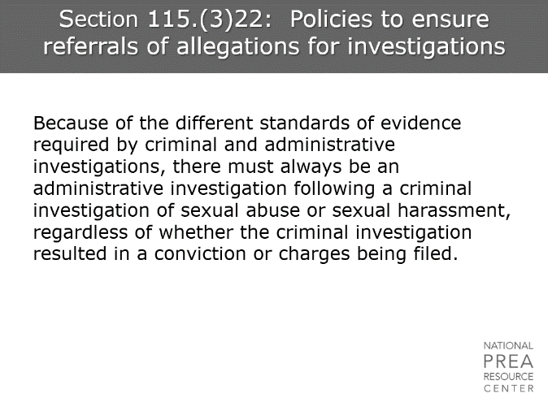 | There are many situations where sexual abuse allegations in particular will require both a criminal and an administrative investigation—since the criminal investigation will focus on violations of law, whereas the administrative investigation will focus on violations of agency policy that may not rise to the level of criminality.  A useful rule of thumb is that any allegation of sexual abuse or sexual harassment that requires a criminal investigation will also require an administrative investigation, regardless of the outcome of the criminal investigation.  Module 8 will discuss the different standards of evidence between criminal and administrative investigations.  A helpful reference for this discussion is the Frequently Asked Question (FAQ) on this standard published on the PREA Resource Center Website, which can be found at: https://www.prearesourcecenter.org/frequently-asked-questions/prea-standard-11522a-requires-administrative-or-emphasis-added-criminal
2 min | Section 115.(3)31: Employee Training  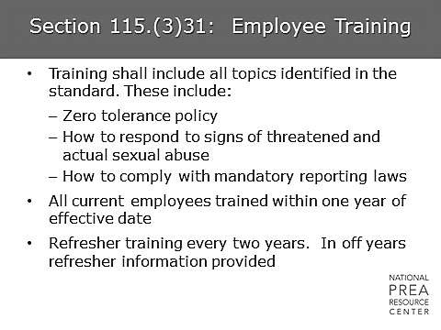  The full list of topics required is:  (1) A zero-tolerance policy for sexual abuse and sexual harassment;  (2) How to fulfill their responsibilities under agency sexual abuse and sexual harassment prevention, detection, reporting, and response policies and procedures;  (3) Inmates/residents’ right to be free from sexual abuse and sexual harassment;  (4) The right of inmates/residents and employees to be free from retaliation for reporting sexual abuse and sexual harassment;  (5) The dynamics of sexual abuse and sexual harassment in confinement;  (6) The common reactions of sexual abuse and sexual harassment victims;  (7) How to detect and respond to signs of threatened and actual sexual abuse;  (8) How to avoid inappropriate relationships with inmates;  (9) How to communicate effectively and professionally with inmates, including lesbian, gay, bisexual, transgender, intersex, or gender nonconforming inmates; and  (10) How to comply with relevant laws related to mandatory reporting of sexual abuse to outside authorities.  The training is also required to be responsive to the gender of the inmates/residents at the facility.  Investigators are also required to receive this training, as are all employees who have contact with inmates/residents. | Section 115.(3)31: Employee Training
2 min | Section 115.(3)33: Inmate/Resident Education  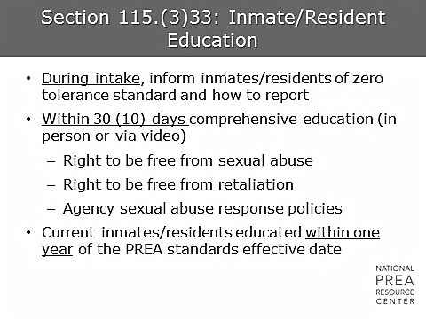  This is one of a number of PREA standards that outline requirements around educating inmates/residents and ensuring inmates/residents have access to the agency’s prevention, detection, and response procedures. Investigators should ensure that inmates/residents with whom they interact are provided with materials or support appropriate to their education level, age, English comprehension, mental health, and/or any disabilities. | Inmate/Resident Education  Trainers should note that the Prison and Jail standards are different in some ways than the standards for juvenile facilities. This standard is one example – the Juvenile standards have a timeline of ten days rather than 30.  Trainers should also note the standard requirements for materials to be accessible to all inmates and residents, including those with disabilities, limited English or reading skills, visual impairment, deafness, etc.
1 min | Section 115.(3)34: Specialized Training-Investigations  Historically, there has been very limited investigator training that is corrections-specific. While many experienced investigators have gained valuable skills from law enforcement training, this standard acknowledges the need for training specific to the corrections environment. This training is designed to address the requirements of this standard. Any state and local police involved in these investigations are also included in the requirements of this standard. | Specialized Training-Investigations
2 min | Section 115.(3)51: Inmate/Resident Reporting  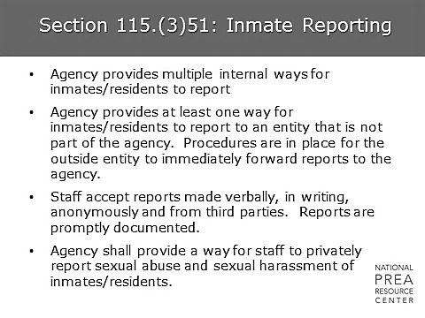  Accessibility of reporting mechanisms is one of the cornerstones of sexual safety. If inmates/residents do not feel that the agency encourages them to report, they will often assume that no action will be taken if they do report. Therefore, there are a number of standards addressing reporting, reporting mechanisms, and response to reports.  Note that this standard also requires the agency to provide staff with a private way to report. This means a way to report that is outside their chain of command. Providing staff with a way to report that is somewhat anonymous will increase the likelihood that they will report unusual behavior. | Inmate/Resident Reporting  Insert agency policy regarding inmate/resident reporting.
2 min | Section 115.(3)61: Staff and Agency Reporting Duties  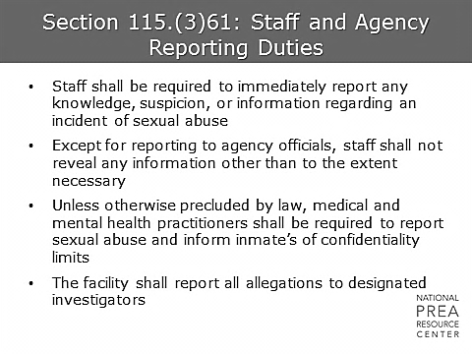  This standard provides specific requirements to staff for reporting. All allegations must be immediately reported and passed on to investigators. This means that staff cannot choose whether to report based on their own determination of whether an allegation is credible or not, or whether the inmate/resident in question has some other purpose for the allegation. Furthermore, the standard requires staff to report all knowledge or suspicions they have regarding sexual abuse or sexual harassment. | Staff and Agency Reporting Duties  Ensure this slide includes a discussion of the final bullet – reporting all allegations to investigators. Some agencies conduct initial investigations to determine whether the allegation is serious enough to report to investigators, as discussed earlier. This does not comply with the standard – all allegations must be investigated by investigators who have been appropriately trained.  Insert agency policy regarding staff reporting.
2 min | Section 115.(3)66: Preservation of Ability to Protect Inmates/Residents from Contact with Abusers  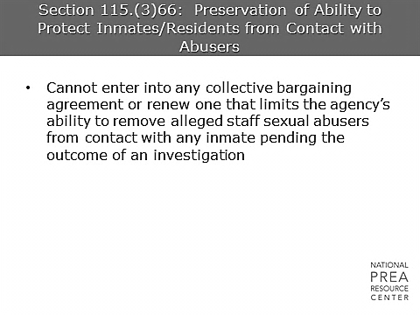  The PREA standards require agencies to avoid entering into or renewing any collective bargaining agreements that limit the agency’s ability to remove alleged staff perpetrators from contact with inmates/residents. | Preservation of Ability to Protect Inmates/Residents from Contact with Abusers  Trainers - if your agency does not have collective bargaining, this slide is not relevant to your agency, so it is recommended that you remove this item.  Ask if participants have any questions.  Insert any relevant information re: agency plans to address this standard.
2 min | Section 115.(3)67: Agency Protection Against Retaliation  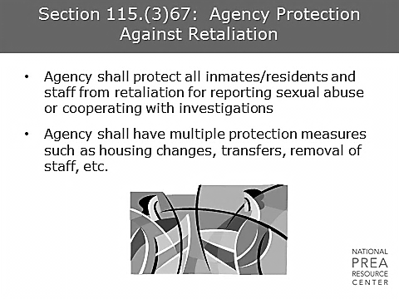  This standard requires the agency to protect those who report or cooperate with investigations against retaliation.  This is extremely important for a number of reasons. Inmates/residents and staff may be more likely to report if they know that the agency has protection measures in place. Other inmates/residents and staff will witness those protection measures and likely have more confidence in the system. This can also work as a prevention measure as reporting becomes more common, and it acts as a deterrent to potential aggressors.  Invisible retaliation is retaliation that is felt by an individual but usually not seen by anyone else. For example, if a staff member reported on another staff member and was fired, that would be (an extreme form of) visible retaliation. Most retaliation is not visible; most retaliation is subtle – shunning by peers, loss of promotions, etc. In the participants’ experience, have they observed invisible retaliation? | Agency Protection Against Retaliation  Insert agency policy for inmates/residents and insert policy for staff.
2 min | Section 115.(3)67: Agency Protection Against Retaliation (continued)  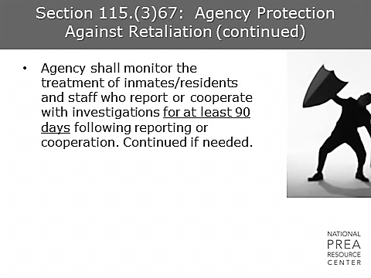  The standard also requires a monitoring function to ensure that the protection measures are working or to establish if protection measures are needed. | Agency Protection Against Retaliation  Insert agency policy here regarding individuals in charge of monitoring and the processes in place for that monitoring. Discuss major components.
2 min | Section 115.(3)71: Criminal and Administrative Agency Investigations  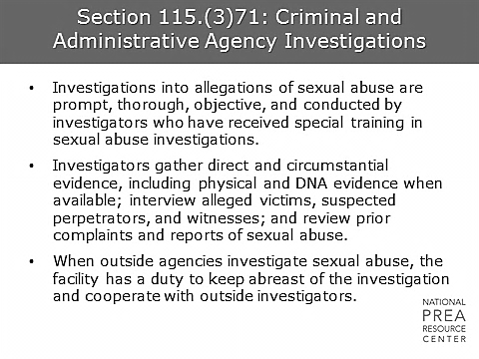  The standards have some basic requirements for investigations, including that they be prompt; that they include interviews with alleged victims, suspects, and witnesses; that the investigator review prior complaints and reports of sexual abuse; and that the investigator gather direct and circumstantial evidence where available. Note that since the standards also require all allegations be investigated, this means that these steps must be taken for all reported allegations.  Additionally, investigators have a responsibility to stay informed on any investigations being conducted by outside agencies and to cooperate with those investigations. | Criminal and Administrative Agency Investigations  This is the main investigative standard. Ensure participants understand that the agency must not only be in compliance with this standard, but they must be in compliance in such a way that they can demonstrate that compliance to auditors.  Insert agency policies if applicable regarding collaboration with outside law enforcement.
2 min | Section 115.(3)71 (continued)  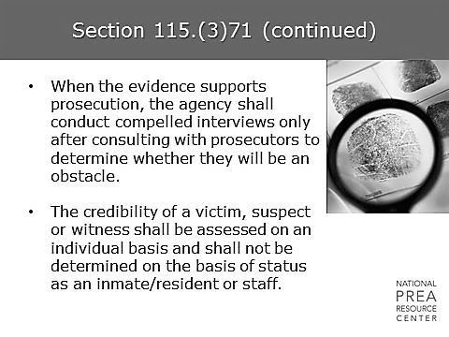  Compelled interviews will be discussed in more depth in Module 2: Legal Issues and Agency Liability. The standards also require that investigators demonstrate that they have conducted credibility assessments of victims, suspects and witnesses on an individual basis, rather than determining credibility based on the individuals’ status as inmate/resident or staff. | Criminal and Administrative Agency Investigations  Compelled interviews will be discussed in more depth in Module 7. Participants should discuss how to document these.  Insert agency directive to investigators regarding compliance with the standard.
2 min | Section 115.(3)71 (continued)  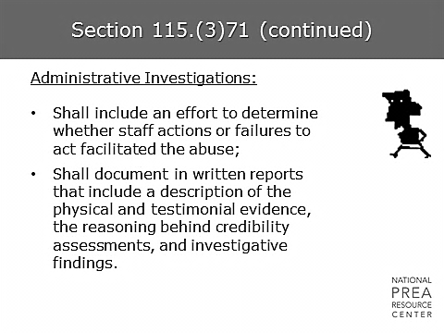  The standards address both administrative and criminal investigations. For administrative investigations, the standards require investigators to determine whether there were actions taken by staff that facilitated the abuse. This will be helpful during the incident reviews that we’ll be discussing later in this module in assisting the agency in determining whether there are policies or practices that should be changed to further enhance sexual safety. The standards additionally require a report including the items on the slide. Every allegation must have an associated report on the investigation. The final module in this training addresses best practices in report writing. | Criminal and Administrative Agency Investigations  Ensure participants understand that every allegation needs a report.
1 min | Section 115.(3)71 (continued)  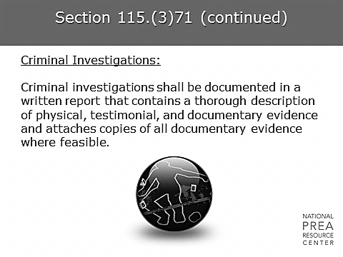  Criminal investigations also require a report that must include specific items. Reports are important to ensure that investigations have appropriate oversight, to assist in demonstrating compliance with the standards, and to ensure investigators are able to potentially testify and speak knowledgeably and credibly regarding any incident that may eventually be prosecuted. | Criminal and Administrative Agency Investigations
2 min | Section 115.(3)71 (continued)  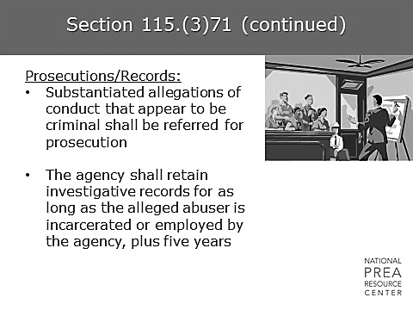  All substantiated allegations of conduct that appear to be criminal are referred to prosecution. Agency investigators or administrators do not determine whether a case can be prosecuted; this will be determined by the local prosecutor.  The standards also provide requirements around retaining records. All records are retained for the entire period of time that the alleged abuser is incarcerated or employed by the agency, plus an additional five years. | Criminal and Administrative Agency Investigations  Ensure participants understand that this standard requires that prosecutors decide whether to prosecute, not the investigators or the agency. Therefore, all investigated allegations are referred to prosecution.  Mention if a prosecutor is coming to speak for the prosecutorial module.
1 min | Section 115.(3)71 (continued)  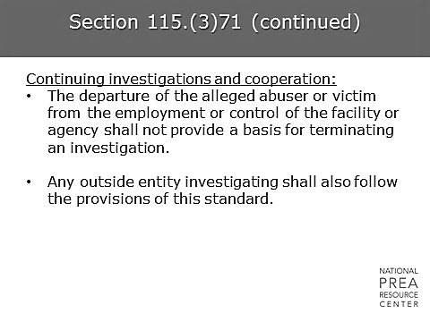  So, if CO John Smith is alleged to be a perpetrator of sexual abuse and he resigns, is the investigation is over? No. It may be more difficult, but the investigation must be completed regardless of whether the alleged abuser or victim leaves the employment or control of the facility or agency. If the suspect/victim is an inmate/resident and they are transferred, agency policy dictates that…  This also links into the standard requirements for reporting to other confinement facilities, which will be discussed later in this module. | Criminal and Administrative Agency Investigations  Insert agency policy here.
2 min | Section 115.(3)72: Evidence Standard for Administrative Investigations  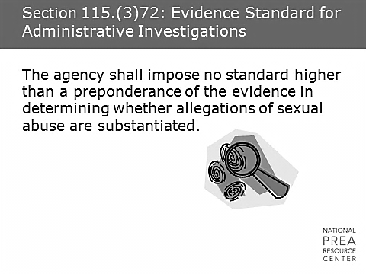  What does “preponderance of the evidence” mean?  It’s typically defined as more than 50% of the evidence. This standard requires that an allegation of sexual abuse be considered substantiated if more than 50% of the evidence indicates that the incident occurred. | Evidence Standard for Administrative Investigations  Note that this standard sets the bar for the highest level that can be required, but not the lowest. Discuss to ensure understanding.
1 min | Section 115.(3)73: Reporting to Inmates/Residents  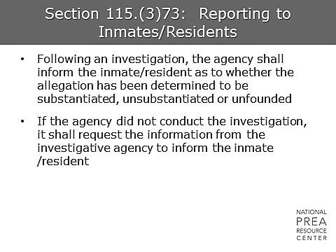  This standard is meant to ensure that inmates/residents who report sexual abuse are informed of the results of the investigations. This will deter inmates/residents from believing that reports are ignored or dismissed without an investigation, which would discourage reporting. | Reporting to Inmates/Residents  Ask: What is the agency currently doing? Discuss.
2 min | Section 115.(3)73: Reporting to Inmates/Residents  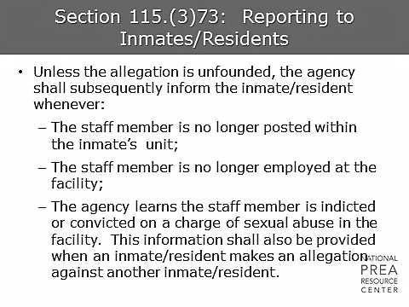 | Reporting to Inmates/Residents  Ask: Do participants currently do this?  Insert agency policy regarding reporting to inmates/resident and the role investigators play in the process.
2 min | Section 115.(3)76: Staff Discipline  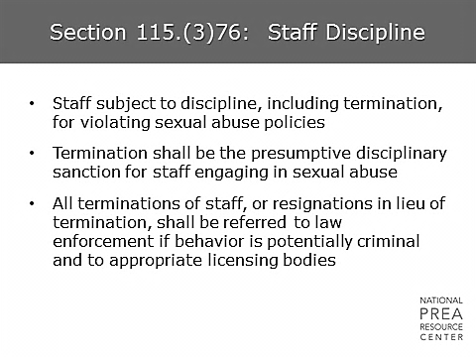  As a deterrent to staff, and as a demonstration of the agency’s commitment to sexual safety, the standards require the agency to make termination the disciplinary sanction for staff engaging in sexual abuse. Any other violations of sexual abuse policies such as assisting another staff member in engaging in sexual abuse or choosing not to report any knowledge or suspicion of sexual abuse will also result in discipline, up to and including termination. Any terminations or resignations of staff who would have been terminated had they not resigned will be referred to law enforcement if their behavior was potentially criminal and to any appropriate licensing bodies. | Staff Discipline  Ask: Do investigators believe staff members are currently subject to discipline if they do not report knowledge or suspicion of sexual abuse or harassment?  Insert agency policy regarding staff discipline for sexual abuse and sexual harassment.
1 min | Section 115.(3)77: Corrective Action for Contractors and Volunteers  Similarly, the standards require corrective action for contractors and volunteers. Those engaging in sexual abuse are prohibited from having contact with inmates/residents and are reported to law enforcement and appropriate licensing bodies. Other violations of policy will result in other remedial measures. | Section 115.(3)77: Corrective Action for Contractors and Volunteers  Insert appropriate agency policies here.
4 min | Section 115.(3)78: Inmate Discipline/Interventions and Disciplinary Sanctions for Residents  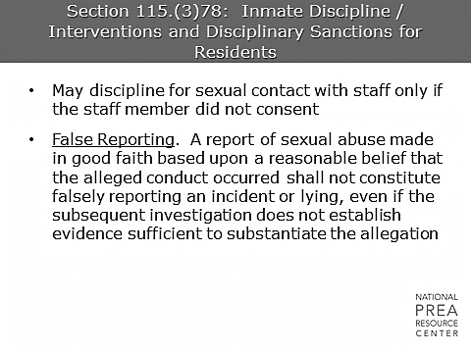  The standards specifically require that agencies do not discipline inmates/residents for sexual contact with staff unless the staff member did not consent. This means that inmates/residents are disciplined only if they assaulted or raped the staff member, and inmates/residents are not disciplined for other sexual contact.  Why do you think the standards included this requirement? What could happen if an agency disciplines an inmate/resident who is the victim of staff sexual misconduct for not cooperating with the investigation? For being in an area of the facility where they’re not supposed to be at the time of the abuse?  This could be perceived as retaliation, which will discourage reporting and can create legal liability for the agency.  False reporting is always of concern in this area, and it is inevitable that some level of false reporting will occur in this and all other areas. However, while agencies are free to discourage false reporting, it is important that the agency doesn’t simultaneously discourage reporting of legitimate sexual abuse concerns. Therefore, the standards require that agencies define false reporting to specifically exclude reports that are made in good faith based upon a reasonable belief that the alleged conduct occurred, even if they are determined to be unfounded. | Inmate Discipline/ Interventions and Disciplinary Sanctions for Residents  Facilitate a discussion on this topic before answering. This is a sensitive topic. Be prepared for varying opinions.  Insert agency policies regarding disciplining inmates/residents.  Insert agency policies regarding false reporting.
1 min | Section 115.(3)86: Sexual Abuse Incident Reviews  The standards require agencies to conduct sexual abuse incident reviews after every allegation. These reviews are conducted by teams that include investigators, and they are designed to ensure any lessons learned from the investigative process are taken into account in agency revision of practice and policy. | Sexual Abuse Incident Reviews  Insert agency policies regarding incident reviews.
1 min | Questions? | Questions?  Ask if the audience has any questions and wrap up the module.

