Agency/Facility Name
PREA REFRESHER: Prisons and Jails
Investigations
Who Investigates PREA Allegations?
- Trained facility investigators conduct internal administrative investigations
- Trained investigators from [investigative agency] conduct criminal investigations, if applicable

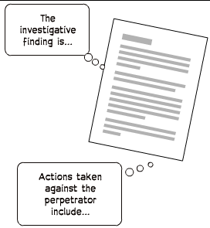
Inmate Notification
Inmates still in custody must be notified:
- Of the investigation’s outcome
- If a staff abuser is no longer allowed to work in an inmate’s unit or facility or has been terminated by our agency
- If this agency learns the alleged [staff/inmate] abuser has been indicted or convicted on a charge related to the sexual abuse allegation
Pixton.com
Possible Investigation Outcomes
Unfounded
The allegation was determined to
have most likely
not occurred

Substantiated
The allegation was determined to
have most likely occurred
Unsubstantiated
It cannot be determined if
the allegation happened

